Address Wizard – Location Address Screen

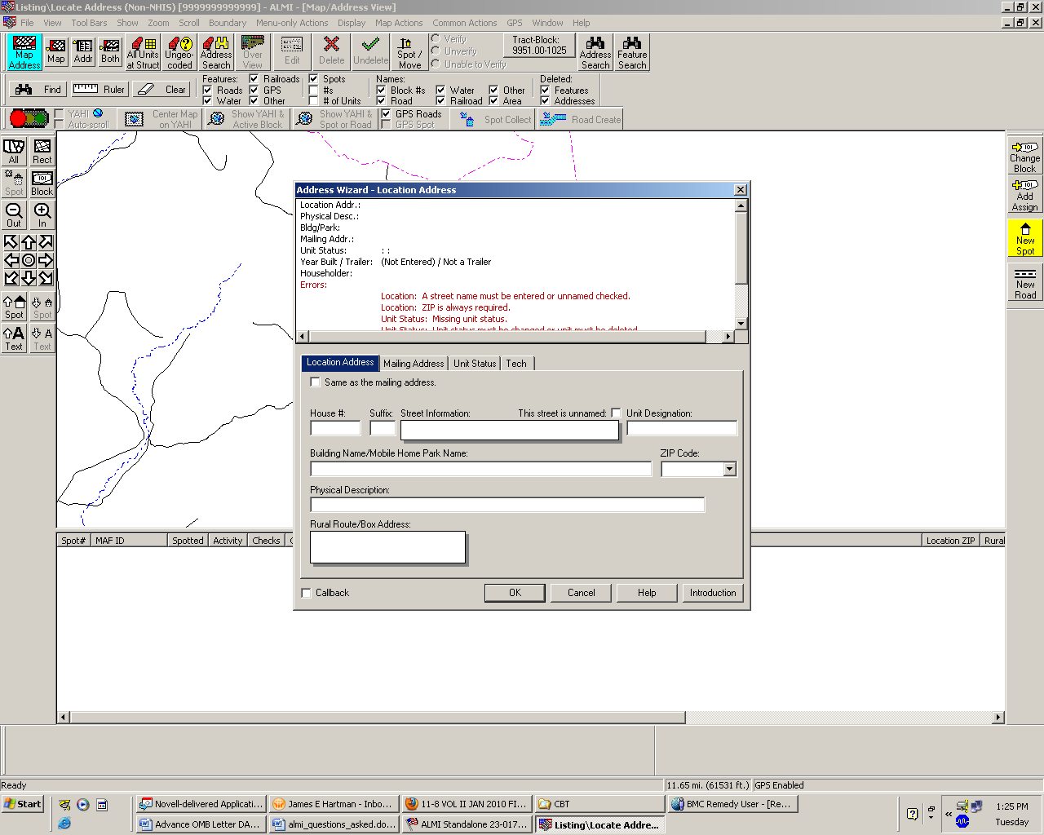

Address Wizard – Mailing Address Screen
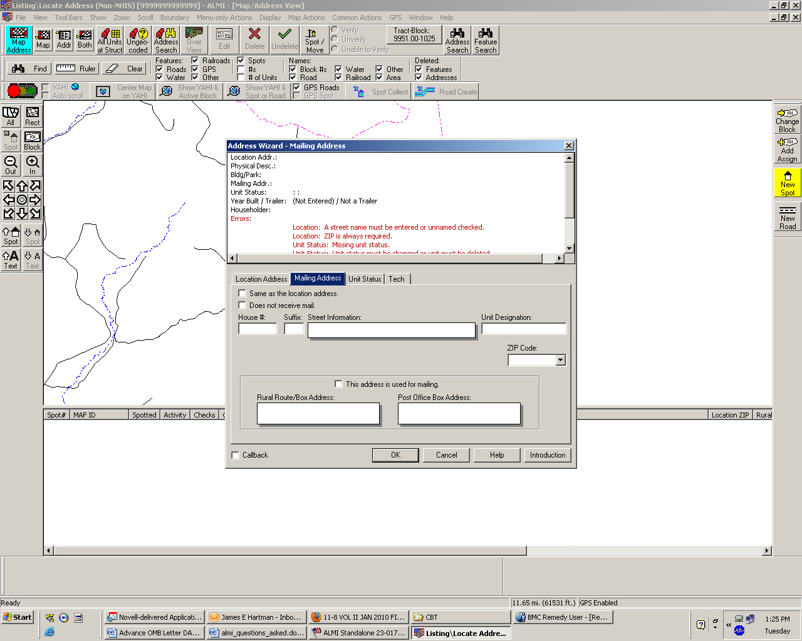
Address Wizard – Unit Status Screen

