Business Portal – Submit a General Comment

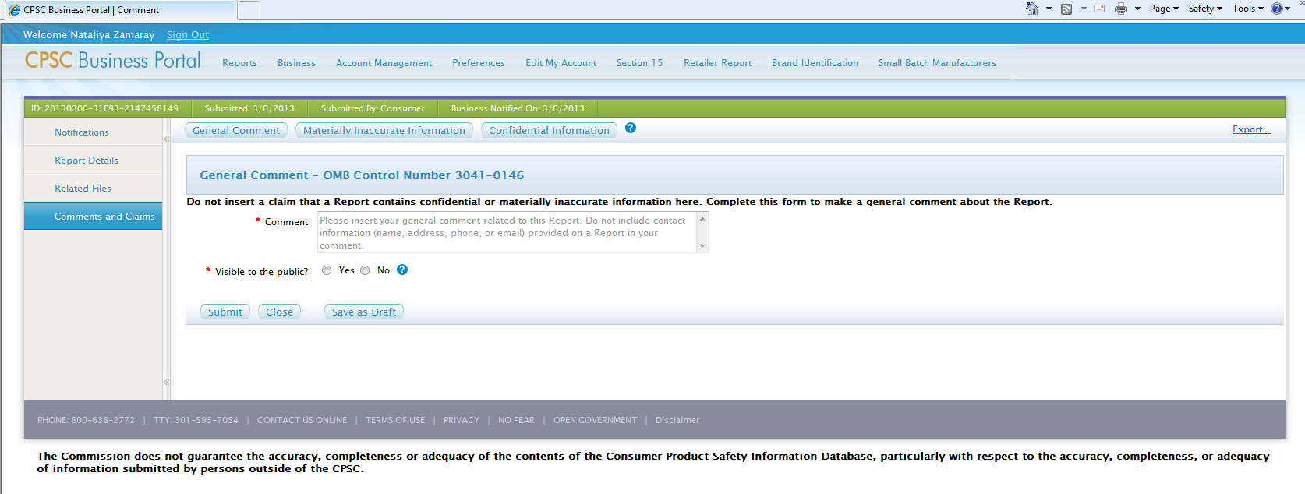

Business Portal – Submit a Materially Inaccurate Information Claim

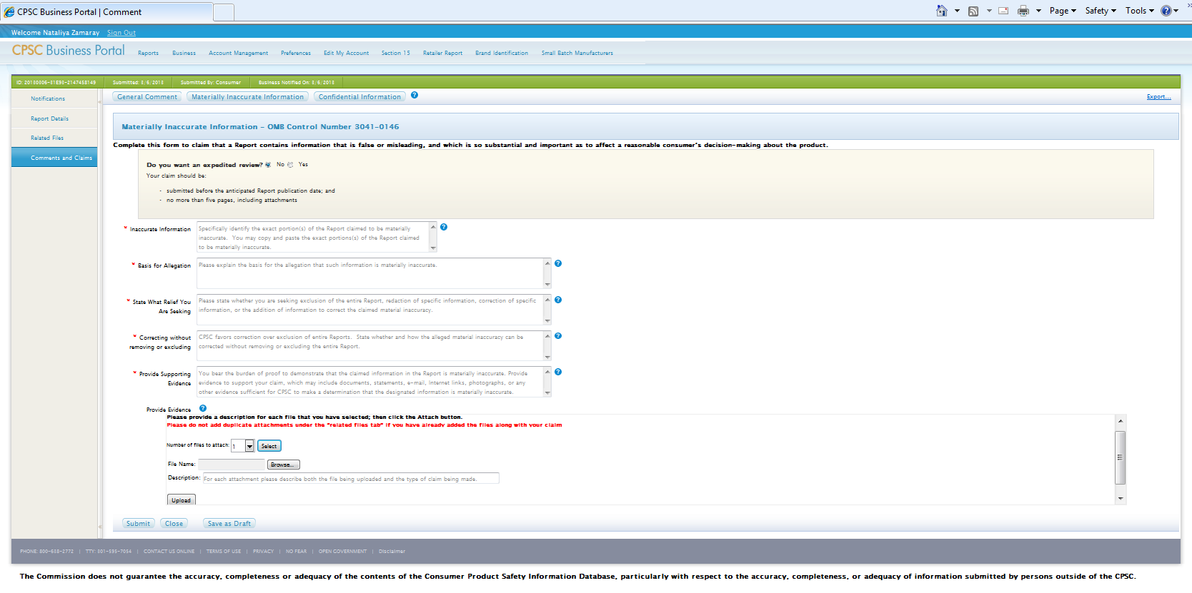

Business Portal – Submit a Confidential Information Claim

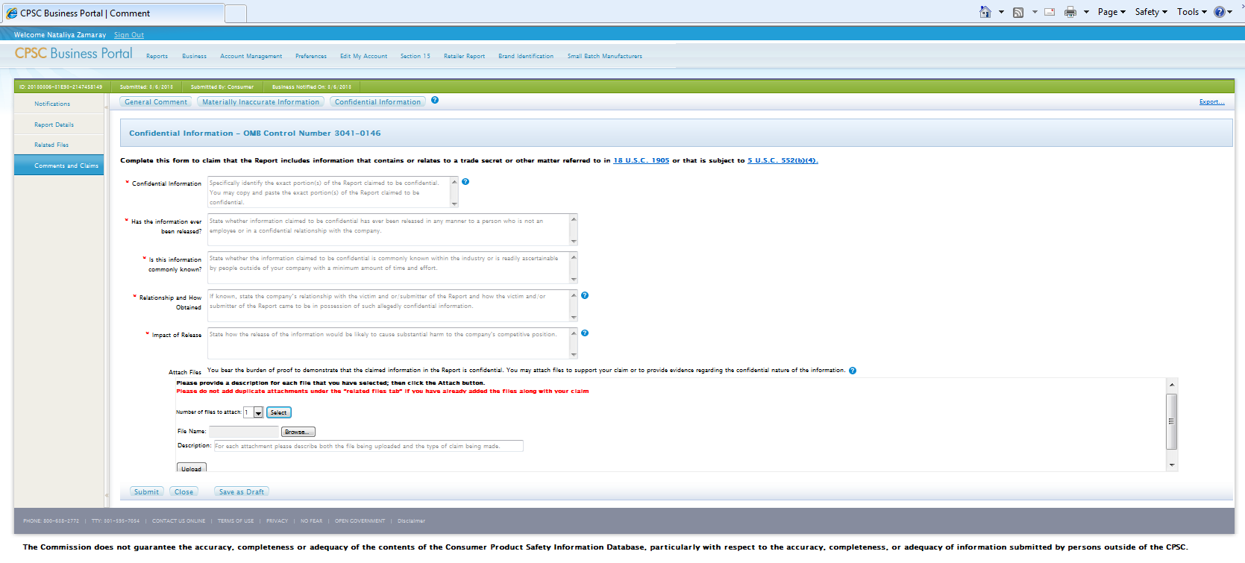

Business Portal – Small Batch Manufacturer Identification

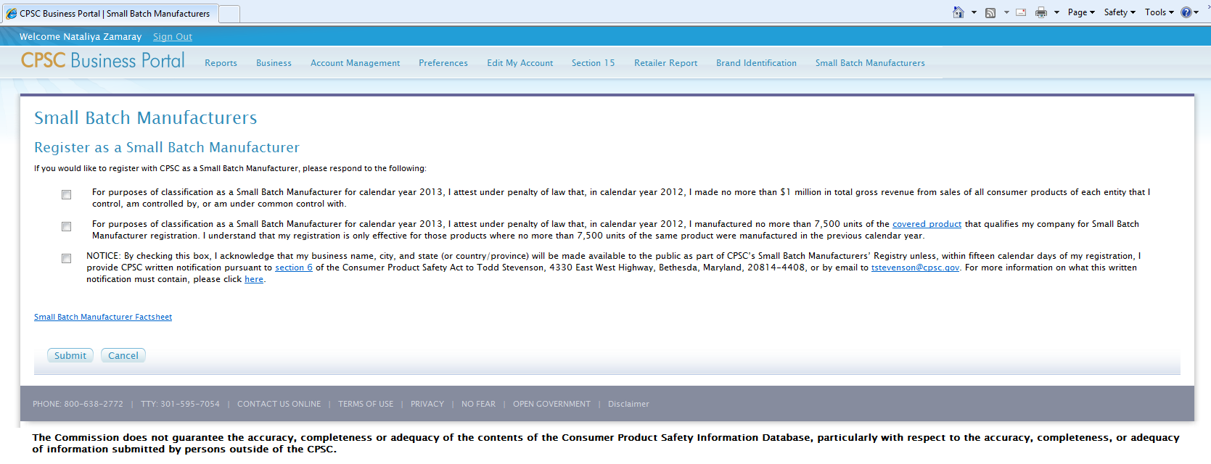

Business Portal – Voluntary Brand Identification

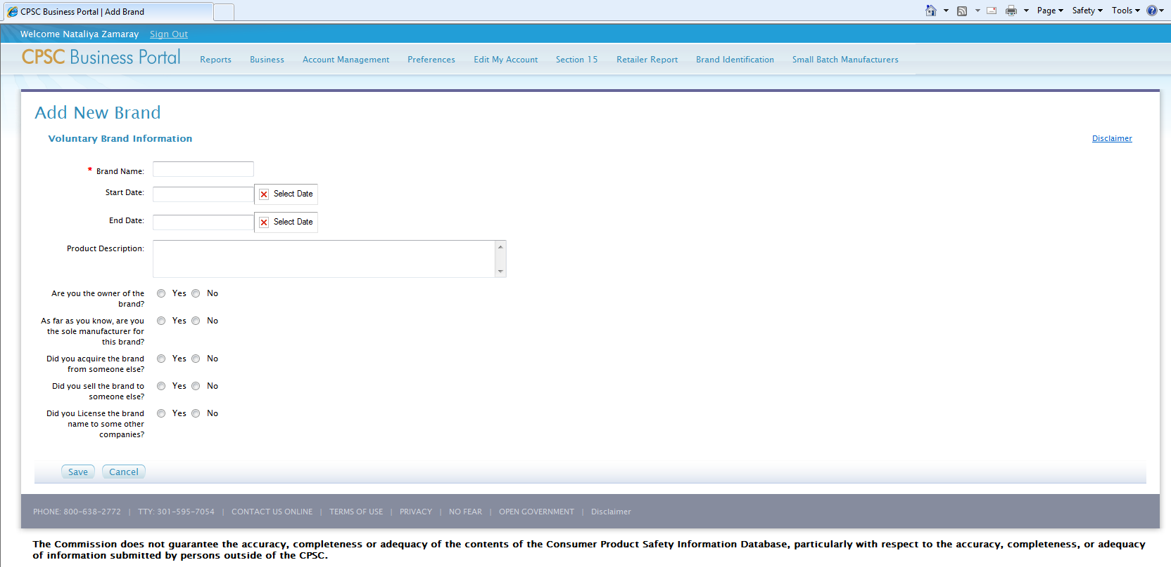

Business Portal – Voluntary Brand Identification

If yes is checked on “Did you acquire the brand from someone else?”, the respondent is prompted with additional questions:

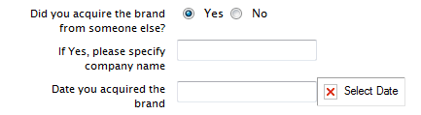

If yes is checked on “Did you sell the brand to someone else”, the respondent is prompted with additional questions:

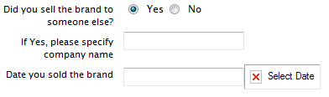

If yes is checked on “Did you License the brand name to some other companies”, the respondent is prompted with additional questions:

