
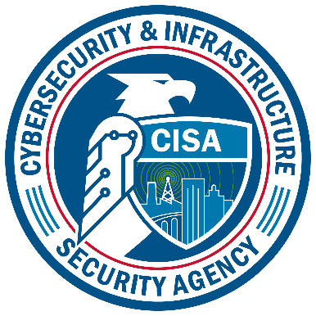
Compliance Assistance Instrument
For inclusion within ICR 1670-0014
Cybersecurity and Infrastructure Security Agency

Paperwork Reduction Act Statement
In accordance with the Paperwork Reduction Act, no one is required to respond to a collection of information unless it displays a valid Office of Management and Budget (OMB) Control Number. The valid OMB Control Number for this information collection is 1670-0014. The time required to complete this information collection is estimated to average 0.08 hours per response, including the time for reviewing instructions, searching existing data sources, gathering and maintaining the data needed, and completing and reviewing the collection of information.

Privacy Notice
Authority: The Protecting and Securing Chemical Facilities from Terrorist Attacks Act of 2014, Pub. L. No. 113-254 which is also codified at 6 U.S.C. § 621 et seq., as amended by Pub. L. No. 116-136, Sec. 16007 (2020) and the Chemical Facility Anti-Terrorism Standards, 6 C.F.R. Part 27 authorize the collection of this information.

Purpose: The primary purpose of this collection is to obtain information regarding a facility's request for Compliance Assistance.

Routine Uses: This information will be used by and disclosed to Department of Homeland Security (DHS) personnel, contractors, or other agents to assist a chemical facility of interest’s request to initiate consultations or seek technical assistance from DHS. This information may also be required in order to contact the facility, if necessary.

Disclosure: Providing this information is voluntary. If you choose not to provide this information, then CISA may not be able to contact you regarding your Compliance Assistance submission.

Basic Reporting Fields
CISA may collect the following basic information:

Identification of CVI Authorized User status
Submitter’s CVI Authorized User Status Number
Name of the Submitter: (Last, First, MI)
Preferred Method of Contact (e.g. phone number, e-mail address).
Phone Number of the Submitter
Facility Name
CSAT Facility ID #
Facility's Address (Street, City, State, Zip)
Date Submitted

Compliance Assistance
In this section, the instrument will collect the following information when a facility requests a consultation or seeks technical assistance about its CFATS regulatory requirements. This instrument also collects information to respond to potentially non-compliant facilities; verify material modifications during the redetermination process; or follow-up on security issues or results of a recent incident.

This instrument collects:

- The name and CVI Authorization number(s) of the individual(s) planning to attend the compliance consultation.
- The reason, for their request, such as:
  - The facility requests a compliance assistance regarding the modification of the facility.
  - The facility requests a compliance assistance regarding the modification of the facility's processes.
  - The facility requests a compliance assistance regarding the modification of the types of materials that the facility possesses.
  - The facility requests a compliance assistance regarding the modification of the quantities of materials that the facility possesses.
  - Other (Narrative).
- Explanation for Request (narrative).
- Proposed date and time for the Compliance Assistance.
- Specific CFATS-related issue(s) of particular interest to the facility.
- Identify the facility's preferred location for the Compliance Assistance and specify whether or not this is a Compliance Assistance to be held at the headquarters of a corporation with multiple CFATS-covered facilities.
- Desired Outcome for Request (narrative).

