Non-substantive Change Request
OMB Control Number 0920-0607
The National Violent Death Reporting System
Date Submitted: 4/18/2025

Summary of request: CDC/NCIPC is requesting a change request to revise questions to align with EO 14168 Defending Women From Gender Ideology Extremism and Restoring Biological Truth to the Federal Government.

Description of Changes Requested: This request updates sex and gender variables used in the National Violent Death Reporting System to be in accordance with EO 14168. Please check the boxes below if your request includes:

x Revision of an existing text/question(s)
x Deletion of an existing text/question(s)

NCIPC deleted the following text on Pg 5 of the SSA:

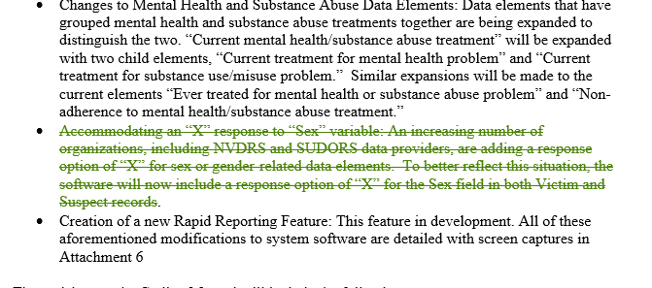

NCIPC revised and deleted the following text on Pg 121 of the coding manual (Att 8)

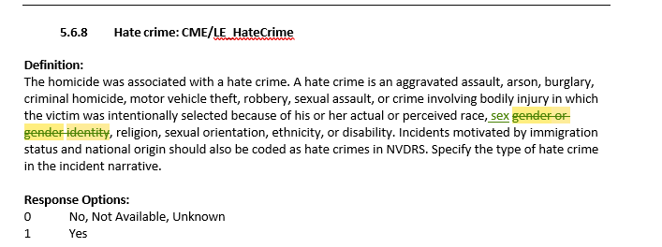

NCIPC deleted the following text on Pg 34 & 35 of the coding manual (Att 8)
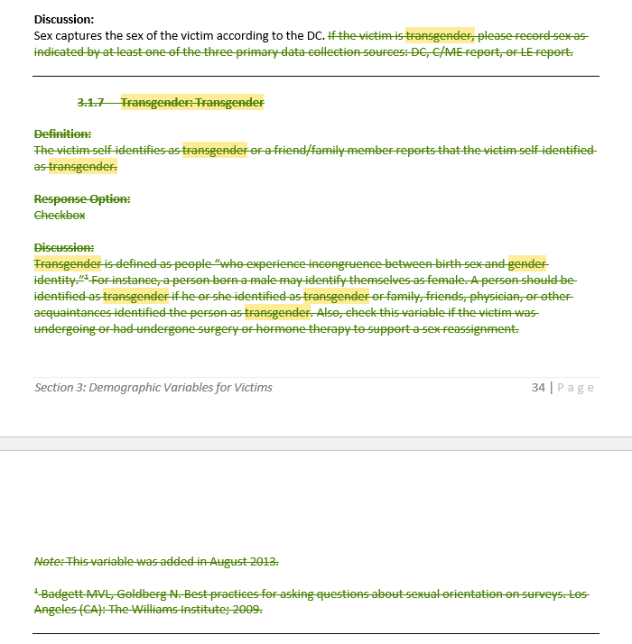

Description of Changes to Burden: There is no change in Burden Hours associated with the modifications made to comply with EO 14168.

