January, 2020
Dear Administrator:

I am writing to request your assistance in helping us conduct an important study called the Medicare Current Beneficiary Survey (MCBS). A resident in your facility has been selected to participate in this study.

Since 1991, the Centers for Medicare and Medicaid Services (CMS), part of the U.S. Department of Health & Human Services, have conducted the MCBS in order to better understand the needs of Americans enrolled in Medicare. It is the nation’s primary source of information about how Medicare affects the people it serves, and we intend to use the information collected to improve the Medicare program. Because we cannot interview everyone on Medicare, a sample of 16,000 Medicare beneficiaries was selected to represent all of those on Medicare.

A portion of the selected Medicare beneficiaries reside in long-term care facilities. These beneficiaries are extremely important to the study because long-term care issues are at the forefront of the national health policy agenda. We need your help to collect information about a resident in your facility. The interview focuses on the utilization and costs of the health care being received by your resident, along with a small section describing the characteristics of your facility. Much of the information can be abstracted directly from the resident’s chart and will only require about an hour of your staff’s time.

No residents of your facility will be contacted directly. All of the information your organization provides will be kept private to the extent permitted by law, as prescribed by The Federal Privacy Act of 1974. Your participation is voluntary, and your relationship with programs administered by CMS will not be affected in any way by whether or not you participate.

NORC at the University of Chicago, a respected social science research organization, has been contracted to conduct the MCBS. A professional interviewer will contact you within the next few weeks to schedule a visit to your facility. Let me emphasize again that your residents’ Medicare benefits cannot be affected in any way by the answers that you provide, or by whether or not you choose to participate.

If you have any questions about the study or would like to schedule an appointment, please call NORC toll-free at 1-877-389-3429, or email NORC at mcbs@norc.org. Enclosed is a brochure that provides you with more information about the survey. You can also visit the MCBS respondent website at www.mcbs.norc.org to learn more. The Medicare Current Beneficiary Survey is important. Please help us in this national effort to improve the Medicare program.

Sincerely,
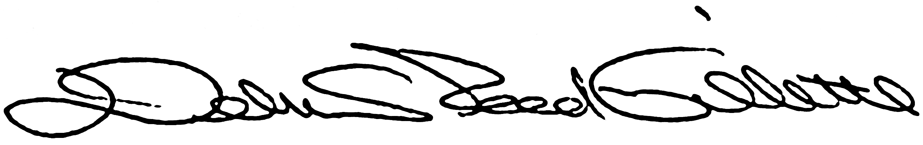
Debra Reed-Gillette

Director, Medicare Current Beneficiary Survey
Centers for Medicare and Medicaid Services

January, 2020

Dear Administrator:
I am writing to address any concerns you may have about your facility’s participation in the Medicare Current Beneficiary Survey (MCBS) as it relates to the Health Insurance Portability and Accountability Act (HIPAA) regulations. Please be assured that the standards of privacy of protected individually identifiable health information implemented under the HIPAA privacy regulation do not affect the data being collected for MCBS. Specifically, your cooperation with the MCBS will not violate the HIPAA privacy regulations. Nor will it require any additional privacy disclosure record keeping.
Under the HIPAA regulations, your facility does not need an individual’s authorization to disclose their protected health information to a health plan, such as the Medicare program, when the information is being disclosed for receiving organization’s health care operations activities. This holds if both your facility and the Medicare program has or had a relationship with the individual whose protected health information is being requested, and the protected information pertains to such relationship. See 45 CFR § 164.506(c) (4). Furthermore, participating in the MCBS will not impose additional disclosure record keeping burdens on your facility. Disclosures under 45 CFR § are explicitly exempt from the HIPAA disclosure accounting provisions. See 45 CFR § 164.528 (a) (1) (i).
I hope this information addresses any questions you had. If you have further questions or concerns about the study, please call me at (410) 786-5525. You may also contact our data collection agent, NORC at the University of Chicago, toll-free at 1-877-389-3429, or email NORC at mcbs@norc.org. You can visit the new MCBS website at www.mcbs.norc.org to learn more. We sincerely hope you will participate in this very important study.

Sincerely,
Debra Reed-Gillette

Director, Medicare Current Beneficiary Survey
Centers for Medicare and Medicaid Services

