US Bureau of Labor Statistics
International Price Program
Import/Export Price Survey website

Server Maintenance message
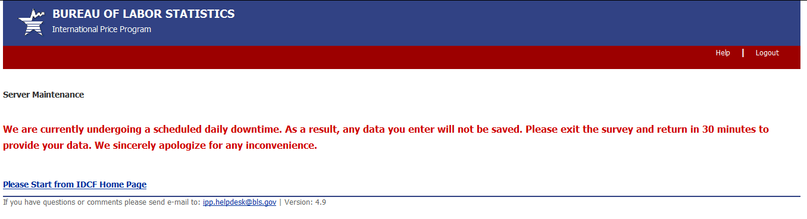

Downtime Message
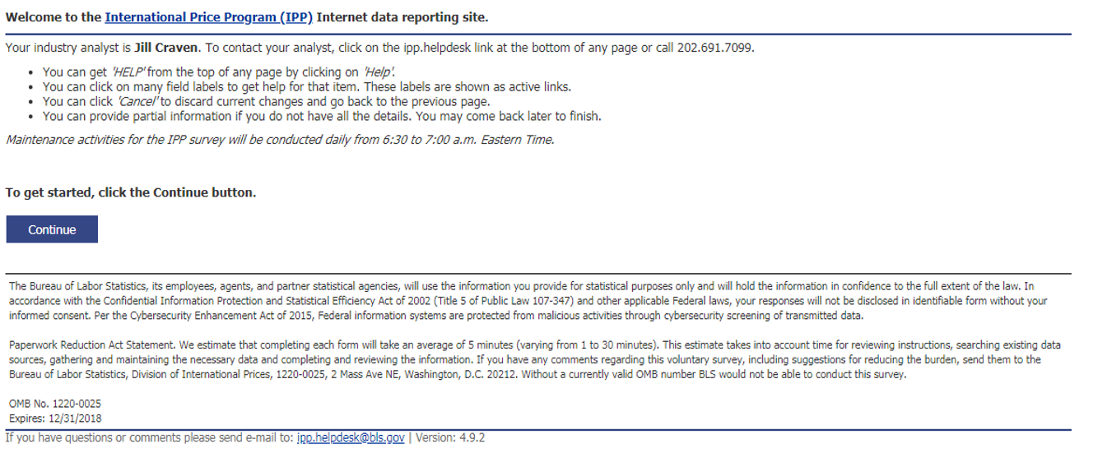

(44 U.S.C. 3572)

