Consumer Expenditure DIARY Survey 2013 Instrument Requirements
Control Card changes
DIARY Section | DIARY CAPI Variable | Change Detail | 2012 DIARY CAPI Wording/Specification | 2013 DIARY CAPI Wording/Specification
Control Card | HHRESP | Replace MCHILD, MAWAY, MLODGE, and MELSE with single question used in SIPP  (Update skip instructions for HHRESP) | * Ask if necessary  With whom am I speaking?  Enter line number  Value/skip instructions:  <1-30, 95> go to MCHILD | Update skip instructions to  <1-30, 95>  go to new variable from SIPP instrument;
Control Card | MCHILD | Replace MCHILD, MAWAY, MLODGE, and MELSE with single question used in SIPP | I have listed …  * Read names  Have I missed ^ANY_ANYOTH babies or small children?  - Yes  - No  Skip instructions:  <1> go to ADD_PERSON  <2, D, R> go to MAWAY | Delete question.
Control Card | MAWAY | Replace MCHILD, MAWAY, MLODGE, and MELSE with single question used in SIPP | Have I missed ^ANY_ANYELSEwho usually lives here but is away now – traveling, at school, or in a hospital?  - Yes  - No  Skip instructions:  <1> go to ADD_PERSON  <2, D, R> go to MLODGE | Delete question.
Control Card | MLODGE | Replace MCHILD, MAWAY, MLODGE, and MELSE with single question used in SIPP | Have I missed ^ANY_ANYOTHL lodgers, boarders, or persons you employ who live here?  - Yes  - No  Skip instructions:  <1> go to ADD_PERSON  <2, D, R> go to MELSE | Delete question.
Control Card | MELSE | Replace MCHILD, MAWAY, MLODGE, and MELSE with single question used in SIPP | Have I missed anyone else staying here?  - Yes  - No  <1> go to ADD_PERSON  <2, D, R> go to CK_SUBFAMILY | Delete question.
Control Card | New question from SIPP instrument | Replace MCHILD, MAWAY, MLODGE, and MELSE with single question used in SIPP | N/A – new question. | 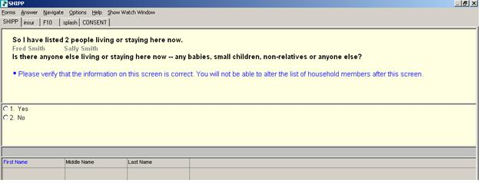  Skip instructions:  <1> go to ADD_PERSON  <2, D, R> go to CK_SUBFAMILY
Control Card  UPDATED | EDUCA  UPDATED 4/3/12 | Collapse education level item codes to match how we use/publish them. | What is the highest level of school ^NamehasYou completed or the highest degree ^NameasYou received?  - Never attended, preschool, kindergarten  - 1st grade  - 2nd grade  - 3rd grade  - 4th grade  - 5th grade  - 6th grade  - 7th grade  - 8th grade  - 9th grade  - 10th grade  - 11th grade  - 12th grade NO DIPLOMA  - HIGH SCHOOL GRADUATE – high school DIPLOMA, or the equivalent  - Some college but no degree  - Associate degree in college – Occupational program  - Associate degree in college – Academic program  - Bachelor’s degree (Example: BA, AB, BS)  - Master’s degree (Example: MA, MS, MEng, MSW, MBA)  - Professional School Degree (Example: MD, DDS, DVM, LLB, JD)  - Doctorate degree (Example: PhD, EdD)  Skip instructions:  <00-11, 38, D, R> if AGE =16-65 OR AGERNG = 8 or 9, go to ARM_FORC;  Else go to BIRTH_MO for next member;  <39-46> go to IN_COLL | What is the highest level of school ^NamehasYou completed or the highest degree ^NameasYou received?  - No schooling completed, or less than 1 year  - Nursery, kindergarten, and elementary (grades 1-8)  - High school (grades 9-12, no degree)  - High school graduate – high school diploma or the equivalent (GED)  - Some college but no degree  - Associate’s degree in college  - Bachelor’s degree (BA, AB, BS, etc.)  - Master’s professional, or doctorate degree (MA, MS, MBA, MD, JD, PhD, etc.)  Skip instructions:  <1-3, D, R> if AGE = 16-65 or AGERNG = 8 or 9, go to ARM_FORC  Else go to AGE1 for next member  <4-8> go to IN_COLL

