NATIONAL CENTER FOR EDUCATION STATISTICS
NATIONAL ASSESSMENT OF EDUCATIONAL PROGRESS

National Assessment of Educational Progress (NAEP) 2022
Materials Update #1

Appendix H1

Long Term Trend (LTT) 2022 Instructions for Entering Student Information

OMB# 1850-0928 v.23

June 2021

Due to COVID-19 school closures in Spring 2020, although LTT 9 and LTT 13 were successfully administered, LTT 17 was not administered on schedule. The materials enclosed are those planned for use in the Spring 2022 administration of LTT 17. NCES is currently planning to administer either LTT age 9 or age 17, which will be decided no later than August 2021.
Appendix H1 provides 3 different versions of Instructions for Entering Student Information – these are differentiated by, number of race/ethnicity columns. The National State Coordinator (NSC) is instructed to decide how many race/ethnicity columns they want the schools to use based on how they collect race data in their state. To avoid schools having to manipulate and collapse any data, we are asking them to submit the data as they are used when they submit these data to the state. Some states collect race/ethnicity data collapsed into one column; some use two columns with ethnicity separated from race; and some have all six race and ethnicity categories separated into six columns.

Table of Contents

Age 17 students, Race/Ethnicity – one column 4
NAEP 2022 LTT 17 Instructions for Preparing and Submitting an Electronic File of Students (One Column Race/Ethnicity) 5
Age 17 students, Race/Ethnicity – two columns 14
NAEP 2022 LTT 17 Instructions for Preparing and Submitting an Electronic File of Students (Two Columns Race/Ethnicity) 15
Age 17 students, Race/Ethnicity – six columns 26
NAEP 2022 LTT 17 Instructions for Preparing and Submitting an Electronic File of Students (Six Columns Race/Ethnicity) 27
Age 9 students, Race/Ethnicity – one column 37
NAEP 2022 LTT 9 Instructions for Preparing and Submitting an Electronic File of Students (One Column Race/Ethnicity) 38
Age 9 students, Race/Ethnicity – two columns 48
NAEP 2022 LTT 9 Instructions for Preparing and Submitting an Electronic File of Students (Two Columns Race/Ethnicity) 49
Age 9 students, Race/Ethnicity – six columns 60
NAEP 2022 LTT 9 Instructions for Preparing and Submitting an Electronic File of Students (Six Columns Race/Ethnicity) 61

Information on Log-in Screen:

Paperwork Burden Statement, OMB Information
According to the Paperwork Reduction Act of 1995, no persons are required to respond to a collection of information unless it displays a valid OMB control number. The valid OMB control number for this voluntary information collection is 1850-0928. The time required to complete this information collection is estimated to be average 120 minutes, including the time to review instructions, search existing data resources, gather the data needed, and complete and review the information collection. If you have any comments concerning the accuracy of the time estimate, suggestions for improving this collection, or any comments or concerns regarding the status of your individual submission of form, please write to: National Assessment of Educational Progress (NAEP), National Center for Education Statistics (NCES), Potomac Center Plaza, 550 12th St., SW, 4th floor, Washington, DC 20202.

OMB No. 1850-0928 APPROVAL EXPIRES 5/31/2024

Authorization and Confidentiality Assurance
The National Center for Education Statistics (NCES) is authorized to conduct NAEP by the National Assessment of Educational Progress Authorization Act (20 U.S.C. §9622) and to collect students’ education records from education agencies or institutions for the purposes of evaluating federally supported education programs under the Family Educational Rights and Privacy Act (FERPA, 34 CFR §§ 99.31(a)(3)(iii) and 99.35). All of the information provided by participants may be used only for statistical purposes and may not be disclosed, or used, in identifiable form for any other purpose except as required by law (20 U.S.C. §9573 and 6 U.S.C. §151). By law, every NCES employee as well as every NCES agent, such as contractors and NAEP coordinators, has taken an oath and is subject to a jail term of up to 5 years, a fine of $250,000, or both if he or she willfully discloses ANY identifiable information about students. Electronic submission of student information will be monitored for viruses, malware, and other threats by Federal employees and contractors in accordance with the Cybersecurity Enhancement Act of 2015. The collected information will be combined across respondents to produce statistical reports.

When you have finished or if you need to stop before finishing, please LOG OUT of the survey system by clicking "Save and exit" and CLOSE ALL browser windows or screens to keep your responses secure. For example, if you used Chrome or Safari to open the survey, make sure no Chrome or Safari windows or screens are open after you end the survey. Not closing all browsers may allow someone else to see your responses.

Age 17 students, Race/Ethnicity – one column

NAEP 2022 LTT 17
Instructions for Preparing and
Submitting an Electronic File of Students
(One Column Race/Ethnicity)
NAEP needs a complete list of students in the selected age group(s) at your school in order to draw a random sample of students to participate in the assessment. Your student data electronic file (E-File) must be submitted as a Microsoft Excel file.
We recommend that you create your student file using the NAEP E-File Excel Template, which is available on the MyNAEP website’s “Submit Student List” page. If necessary, you may alternatively provide an Excel file with the same column headers and data in a different order. If you cannot submit your student data in an Excel file, call the NAEP help desk at 1-800-283-6237.
Step 1 – The E-Filing Template
Download and review the E-Filing Template. Note the column headers (fields) that must be included in your student list. If you do not have data for a particular field, you may leave that column blank.
Step 2 – Compile Data for the Template
Prepare and submit a separate Excel file of all students in your school with birthdates between October 1, 2004 and September 30, 2005. Students may be in any grade, however, we expect most of the students to be in the following grades: 9, 10, 11, and 12.
- Include in the file data for all students in the age group, even those students who typically may be excluded from other testing programs, such as students with IEPs (SD) and English Learners (EL). Make sure there are no duplicate students in your file.
- Make sure you provide information for all students in the sampled age group, including students participating in virtual/remote learning due to COVID-19.
- Also include students in the age group who were displaced from other locations due to hurricanes and other disasters.
- If this is a year-round school, include students who will be on break/on vacation on the scheduled assessment day along with all of the other students in the sampled age group. The NAEP E-File Excel Template contains an “On Break” column you will use to identify those students who will be on break/on vacation by filling in “Yes.” (If you are not using the template, be sure to create and provide data for an “On Break” column in your file.)
Your Excel file must contain the following data:
Excel Header/  Field Name | NAEP Values | Comments
State unique Student ID | N/A | If available; do not use the student’s Social Security number
Student First Name | N/A | Text; must be in its own column
Student Middle Name | N/A | Text; Middle Name is optional, but the column must be included in the Excel file
Student Last Name | N/A | Text; must be in its own column
Grade in School | Any | Use current year data
Homeroom or other Locator | N/A | If available; locator information is helpful in finding students and notifying them of the assessment
Month of Birth | M or MM (numeric format) | Numeric format; must be in its own column
Year of Birth | YYYY (numeric format)  The expected ranges for Year of Birth are listed below:  2004–2005 | Numeric format; must be in its own column
Sex | School-defined codes: | Codes (numeric or text) for Male/Female
Race/Ethnicity – one column | School-defined codes for  - Hispanic, of any race: A person of Mexican, Puerto Rican, Cuban, Central or South American, or other Spanish (but not Portuguese) culture of origin, regardless of race  - White, not Hispanic: A person having origins in any of the original peoples of Europe (except Spain), North Africa, or the Middle East  - Black or African American, not Hispanic: A person having origins in any of the Black peoples of Africa  - Asian, not Hispanic: A person having origins in any of the original peoples of the Far East, Southeast Asia, the Indian Subcontinent, including, for example, Cambodia, China, Japan, India, Korea, Malaysia, Pakistan, the Philippine Islands, Thailand, and Vietnam  - American Indian or Alaska Native, not Hispanic: A person having origins in any of the original peoples of North and South America (including Central America), and who maintains tribal affiliation or community attachment  - Native Hawaiian or Pacific Islander, not Hispanic: A person having origins in any of the original people of Hawaii, Guam, Samoa, or other Pacific Islands  - Two or More Races, not Hispanic: A person who identifies with two or more of the non-Hispanic categories above  - School does not collect this information: Available to nonpublic schools only. When used, this code must be applied to all students.  - Information unavailable at this time: If you currently do not have this information for one or more students, blank cells or an indicator such as “N/A” (Not Available) in the cell(s) can be mapped to this code to notify your NAEP representative of the need to collect the data at a later date. | Use ONE code per student, text or numeric
National School Lunch Program (NSLP) | School defined codes for  - Student not eligible to participate: Student is not eligible for free or reduced-price lunch  - Free lunch: Student is eligible for free lunch. Schools participating in Provisions 2 or 3 of the NSLP should code all students as “free lunch.”  - Reduced-price lunch: Student is eligible for reduced-price lunch  - School not participating: School does not participate in the NSLP. When used, this code must be applied to all students.  - Information unavailable at this time: If you currently do not have this information for one or more students, blank cells or an indicator such as “N/A” (Not Available) in the cell(s) can be mapped to this code to notify your NAEP representative of the need to collect the data at a later date. | Use ONE code per student, text or numeric
SPECIAL INSTRUCTIONS FOR CEP SCHOOLS: If your school participates in the Community Eligibility Provision (CEP), note that for NAEP, only students who are economically disadvantaged students can be classified as eligible for free or reduced-price lunch.
---------------------------------------------------------------------------------------------
CEP Direct Only
In CEP schools in our state, economically disadvantaged students are those who are directly certified through participation in assistance programs such as the Supplemental Nutrition Assistance Program (SNAP) and the Temporary Assistance for Needy Families (TANF).

Please code your students as follows:

Is the student economically disadvantaged? | How should student be coded on NAEP?
1. Yes | 1. Eligible for free or reduced-price lunch
2. No | 2. Student not eligible
3. Information missing | 3. Information unavailable
---------------------------------------------------------------------------------------------
CEP Direct Certification Plus
In CEP schools in our state, economically disadvantaged students are identified in two ways: a) directly certified through participation in assistance programs, such as the Supplemental Nutrition Assistance Program (SNAP) and the Temporary Assistance for Needy Families (TANF); b) through a household income survey.

Please code your students as follows:

Is the student economically disadvantaged? | How should student be coded on NAEP?
- Yes | 1. Eligible for free or reduced-price lunch
- No | 2. Student not eligible
- Information missing | 3. Information unavailable

CEP All
In our state, all students in CEP schools are considered economically disadvantaged.

Please code your students as follows:

Is the student economically disadvantaged? | How should student be coded on NAEP?
1. Yes | 1. Eligible for free lunch

Students with Disabilities (SD) | School defined codes for  - Yes, IEP: Student has a formal Individualized Education Program (IEP), the student’s IEP is in progress, or the student has an equivalent classification for private schools. If some students have both an IEP and a 504 Plan, code these students as “Yes, IEP.”  - No, not SD: Student does not have an IEP. If students have a 504 Plan without an IEP, code these students as “No, not SD.”  - Information unavailable at this time: If you currently do not have this information for one or more students, blank cells or an indicator such as “N/A” (Not Available) in the cell(s) can be mapped to this code to notify your NAEP representative of the need to collect the data at a later date. | Use ONE code per student, text or numeric
English Learner (EL) | School-defined codes for  - Yes, EL  - No, Not EL  - No, Formerly EL: If a student has achieved full English proficiency within the previous 2 years and the state includes formerly EL students in its accountability reports, the student should be coded as “No, formerly EL.” Public schools, contact your NAEP State Coordinator if you have any questions about using this code.  - Information unavailable at this time: If you currently do not have this information for one or more students, blank cells or an indicator such as “N/A” (Not Available) in the cell(s) can be mapped to this code to notify your NAEP representative of the need to collect the data at a later date. | Use ONE code per student, text or numeric
On-Break Indicator | School-defined code | Only for year-round schools; column can be left off if school is not year-round
Student ZIP Code | Numeric only | If available; format can be five digits or five plus four

Tips for ensuring the E-File process goes smoothly
- The NAEP E-File template should be used if possible. Please use it as is. Do not change the column headers. Student information must begin on the second row. There should be no empty rows between the headings and the student data or within the student data, and no headings within the data.
- If you are not able to use the NAEP E-File Excel Template (for example, because of the way your data system works), the columns in your Excel E-File should have the same, or similar, names but do not have to be in any particular order. You will be able to identify the contents of each column after you have submitted your file. (For example, you will be able to indicate that your column labeled “Gender” is what provides the NAEP “Sex” information, and your value of “1” is “Male” and a “2” is “Female,” or whatever the correct interpretation.)
- Be sure to give your file a unique, descriptive name. Select “File,” then “Save As,” and give it a name such as “Your School Name Age 17.xls.” Should you need to reference your file again, this will help you locate it after E-Filing.
- The first row of data in your file will be read as the column header unless you indicate otherwise on the E-Filing “Welcome” page. Each succeeding row will be considered a student record.
- If you merge or cut and paste data from another Excel file into the template, review the file afterward to be sure there are properly aligned student data in every row and there are no column headers or blank rows in the middle of the data.
- Be sure that your file contains only a heading row and student data, not notes or text in additional columns, or they will be read as data resulting in a warning or error message.
- There should be only one worksheet with data in the Excel file. If there are other worksheets, they must not contain any data.
Step 3 – E-File
Once your file is prepared and checked for accuracy and completeness, log in to the MyNAEP website and select “Submit Student List” from the left-hand menu.
- Select the “Start E-Filing Age 17” button.
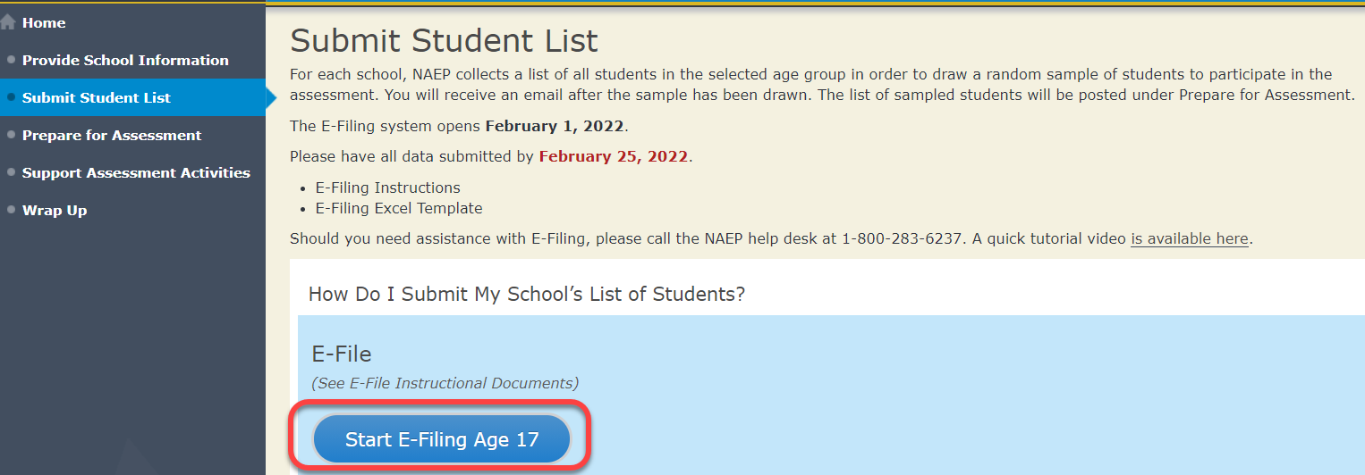
- You will see a checklist on the next screen; please review it carefully to be sure your file is set up correctly and is ready to be submitted. Then select “Continue.”

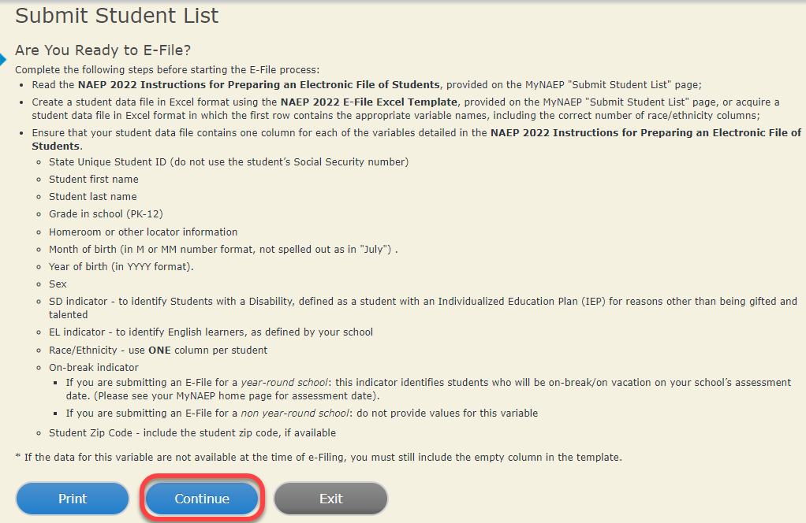
- Enter the required fields and then browse for the name of your file and select “Upload.”
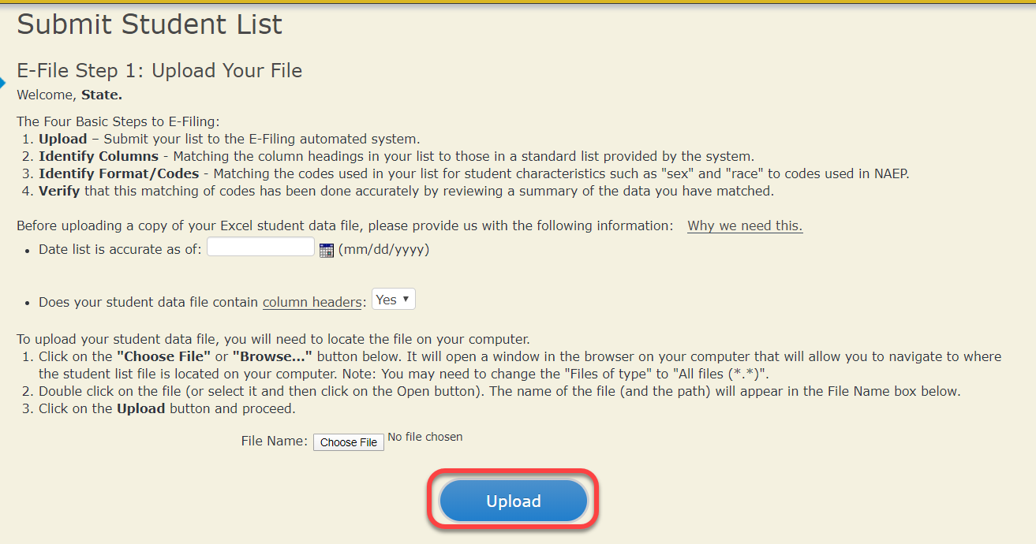

Step 4 – Map Your Columns and Rows to NAEP Values
The field names used by your database system may not have the same names as the NAEP values. You will need to match the names of your columns to the names of the NAEP columns, and then, match row values to NAEP values.
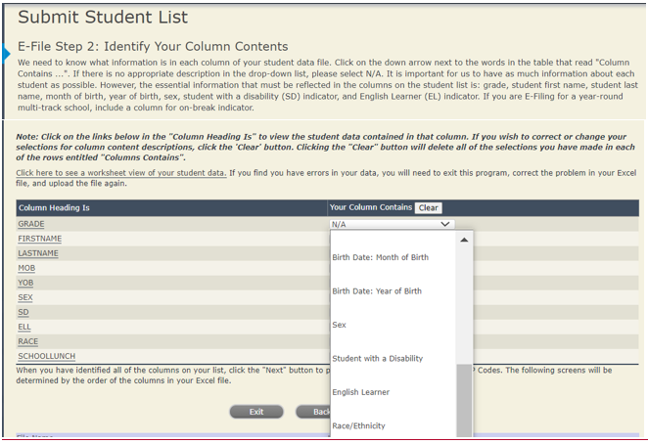

Shown below is an example of row mapping. You need to match the values in each of your columns to the NAEP codes (in drop-down). Once you map a value, select “Next” to move to the next value.
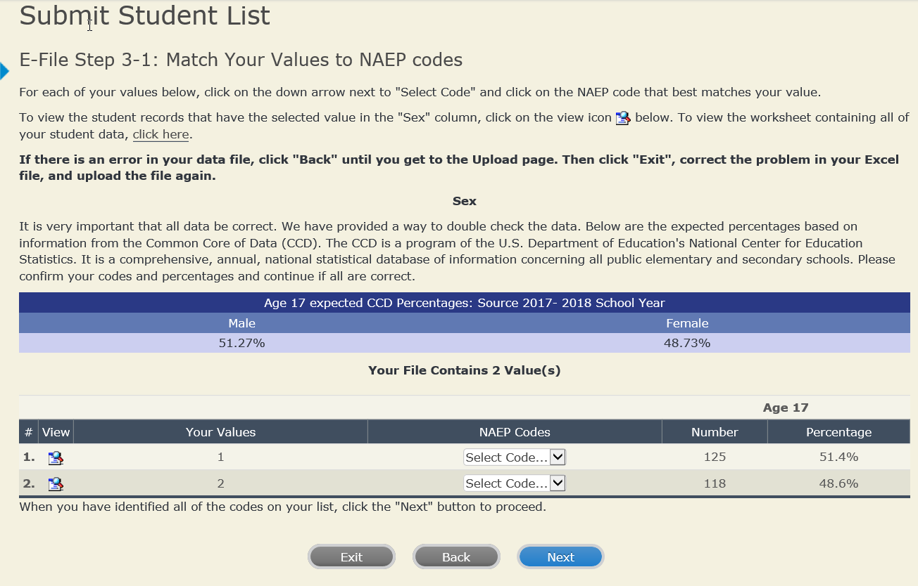
Step 5 – Review Warnings and Verify Data

When you finish row mapping, the E-Filing process will continue and a series of E-File checks will be run. These checks may produce warnings that you will need to review. If you find there are problems with your data, you can return to any mapping page to make any necessary changes. If your data are incorrect, you can choose “Start Over” and resubmit a new corrected file. If your data are correct, select “Continue” to move to the next screen.
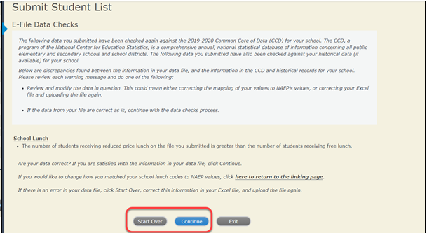
The next screen will show you a table that summarizes the data in your file. If you verify your data as correct, you need to select “Information is Correct” and then “Submit.”
If your data are incorrect, you should select “Information is Incorrect” or select “Back” and then “Start Over” to submit a new list. 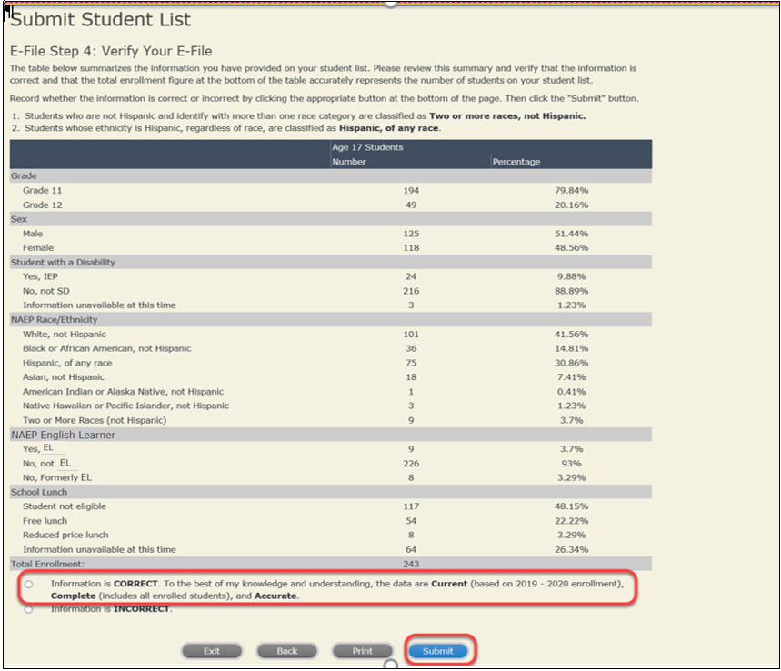

If you need assistance, call the NAEP help desk at 1-800-283-6237.

Age 17 students, Race/Ethnicity – two columns

NAEP 2022 LTT 17
Instructions for Preparing and
Submitting an Electronic File of Students
(Two Columns Race/Ethnicity)
NAEP needs a complete list of students in the selected age group(s) at your school in order to draw a random sample of students to participate in the assessment. Your student data electronic file (E-File) must be submitted as a Microsoft Excel file.
We recommend that you create your student file using the NAEP E-File Excel Template, which is available on the MyNAEP website’s “Submit Student List” page. If necessary, you may alternatively provide an Excel file with the same column headers and data in a different order. If you cannot submit your student data in an Excel file, call the NAEP help desk at 1-800-283-6237.
Step 1 – The E-Filing Template
Download and review the E-Filing Template. Note the column headers (fields) that must be included in your student list. If you do not have data for a particular field, you may leave that column blank.
Step 2 – Compile Data for the Template
Prepare and submit a separate Excel file of all students in your school with birthdates between October 1, 2004 and September 30, 2005. Students may be in any grade, however, we expect most of the students to be in the following grades: 9, 10, 11, and 12.
- Include in the file data for all students in the age group, even those students who typically may be excluded from other testing programs, such as students with IEPs (SD) and English learners (EL). Make sure there are no duplicate students in your file.
- Make sure you provide information for all students in the sampled age group, including students participating in virtual/remote learning due to COVID-19.
- Also include students in the age group who were displaced from other locations due to hurricanes and other disasters.
- If this is a year-round school, include students who will be on break/on vacation on the scheduled assessment day along with all of the other students in the age group. The NAEP E-File Excel Template contains an “On Break” column you will use to identify those students who will be on break/on vacation by filling in “Yes.” (If you are not using the template, be sure to create and provide data for an “On Break” column in your file.)
Your Excel file must contain the following data:
Excel Header/  Field Name | NAEP Values | Comments
State unique Student ID | N/A | If available; do not use the student’s Social Security number
Student First Name | N/A | Text; must be in its own column
Student Middle Name | N/A | Text; Middle Name is optional, but the column must be included in the Excel file
Student Last Name | N/A | Text; must be in its own column
Grade in School | Any | Use current year data
Homeroom or other Locator | N/A | If available; locator information is helpful in finding students and notifying them of the assessment
Month of Birth | M or MM (numeric format) | Numeric format; must be in its own column
Year of Birth | YYYY (numeric format)  The expected ranges for Year of Birth are listed below:  2004–2005 | Numeric format; must be in its own column
Sex | School-defined codes | Codes (numeric or text) for Male/Female
Ethnicity (Hispanic or not) | School-defined codes for  - Yes, Hispanic: A person of Mexican, Puerto Rican, Cuban, Central or South American, or other Spanish (but not Portuguese) culture of origin, regardless of race  - No, Not Hispanic  - Information unavailable at this time: If you currently do not have this information for one or more students, blank cells or an indicator such as “N/A” (Not Available) in the cell(s) can be mapped to this code to notify your NAEP representative of the need to collect the data at a later date. | Use ONE code per student, text or numeric
Race | School-defined codes for  - White: A person having origins in any of the original peoples of Europe, North Africa, or the Middle East  - Black or African American: A person having origins in any of the Black peoples of Africa  - Asian: A person having origins in any of the original peoples of the Far East, Southeast Asia, the Indian Subcontinent, including, for example, Cambodia, China, Japan, India, Korea, Malaysia, Pakistan, the Philippine Islands, Thailand, and Vietnam  - American Indian or Alaska Native: A person having origins in any of the original peoples of North and South America (including Central America), and who maintains tribal affiliation or community attachment  - Native Hawaiian or Pacific Islander: A person having origins in any of the original people of Hawaii, Guam, Samoa, or other Pacific Islands  - Two or More Races: A person who identifies with two or more of the race categories above  - School does not collect this information: Available to nonpublic schools only. When used, this code must be applied to all students.  - Information unavailable at this time: If you currently do not have this information for one or more students, blank cells or an indicator such as “N/A” (Not Available) in the cell(s) can be mapped to this code to notify your NAEP representative of the need to collect the data at a later date. | Use ONE code per student, text or numeric
National School Lunch Program (NSLP) | School defined codes for  - Student not eligible to participate: Student is not eligible for free or reduced-price lunch  - Free lunch: Student is eligible for free lunch. Schools participating in Provisions 2 or 3 of the NSLP should code all students as “free lunch.”  - Reduced price lunch: Student is eligible for reduced-price lunch  - School not participating: School does not participate in the NSLP. When used, this code must be applied to all students.  - Information unavailable at this time: If you currently do not have this information for one or more students, blank cells or an indicator such as “N/A” (Not Available) in the cell(s) can be mapped to this code to notify your NAEP representative of the need to collect the data at a later date. | Use ONE code per student, text or numeric
SPECIAL INSTRUCTIONS FOR CEP SCHOOLS: If your school participates in the Community Eligibility Provision (CEP), note that for NAEP, only students who are economically disadvantaged students can be classified as eligible for free or reduced-price lunch.
---------------------------------------------------------------------------------------------
CEP Direct Only
In CEP schools in our state, economically disadvantaged students are those who are directly certified through participation in assistance programs such as the Supplemental Nutrition Assistance Program (SNAP) and the Temporary Assistance for Needy Families (TANF).

Please code your students as follows:

Is the student economically disadvantaged? | How should student be coded on NAEP?
1. Yes | 1. Eligible for free or reduced-price lunch
2. No | 2. Student not eligible
3. Information missing | 3. Information unavailable
---------------------------------------------------------------------------------------------
CEP Direct Certification Plus
In CEP schools in our state, economically disadvantaged students are identified in two ways: (a) directly certified through participation in assistance programs such as the Supplemental Nutrition Assistance Program (SNAP) and the Temporary Assistance for Needy Families (TANF); (b) through a household income survey.

Please code your students as follows:

Is the student economically disadvantaged? | How should student be coded on NAEP?
- Yes | 1. Eligible for free or reduced-price lunch
- No | 2. Student not eligible
- Information missing | 3. Information unavailable

CEP All
In our state, all students in CEP schools are considered economically disadvantaged.

Please code your students as follows:

Is the student economically disadvantaged? | How should student be coded on NAEP?
1. Yes | 1. Eligible for free lunch

Students with Disabilities (SD) | School-defined codes for  - Yes, IEP: Student has a formal Individualized Education Program (IEP), the student’s IEP is in progress, or the student has an equivalent classification for private schools. If some students have both an IEP and a 504 Plan, code these students as “Yes, IEP.”  - No, not SD: Student does not have an IEP. If students have a 504 Plan without an IEP, code these students as “No, not SD.”  - Information unavailable at this time: If you currently do not have this information for one or more students, blank cells or an indicator such as “N/A” (Not Available) in the cell(s) can be mapped to this code to notify your NAEP representative of the need to collect the data at a later date. | Use ONE code per student, text or numeric
English Learner (EL) | School-defined codes for  - Yes, EL  - No, Not EL  - No, Formerly EL: If a student has achieved full English proficiency within the previous 2 years and the state includes formerly EL students in its accountability reports, the student should be coded as “No, formerly EL.” Public schools, contact your NAEP State Coordinator if you have any questions about using this code.  - Information unavailable at this time: If you currently do not have this information for one or more students, blank cells or an indicator such as “N/A” (Not Available) in the cell(s) can be mapped to this code to notify your NAEP representative of the need to collect the data at a later date. | Use ONE code per student, text or numeric
On-Break Indicator | School-defined code | Only for year-round schools; column can be left off if school is not year-round
Student ZIP Code | Numeric only | If available; format can be five digits or five plus four

Tips for ensuring the E-File process goes smoothly
- The NAEP E-File template should be used if possible. Please use it as is. Do not change the column headers. Student information must begin on the second row. There should be no empty rows between the headings and the student data or within the student data, and no headings within the data.
- If you are not able to use the NAEP E-File Excel Template (for example, because of the way your data system works), the columns in your Excel E-File should have the same, or similar, names but do not have to be in any particular order. You will be able to identify the contents of each column after you have submitted your file. (For example, you will be able to indicate that your column labeled “Gender” is what provides the NAEP “Sex” information, and your value of “1” is “Male” and a “2” is “Female,” or whatever the correct interpretation.)
- Be sure to give your file a unique, descriptive name. Select “File,” then “Save As,” and give it a name such as “Your School Name Age 17.xls.” Should you need to reference your file again, this will help you locate it after E-Filing.
- The first row of data in your file will be read as the column header unless you indicate otherwise on the E-Filing “Welcome” page. Each succeeding row will be considered a student record.
- If you merge or cut and paste data from another Excel file into the template, review the file afterward to be sure there are properly aligned student data in every row and there are no column headers or blank rows in the middle of the data.
- Be sure that your file contains only a heading row and student data, not notes or text in additional columns, or they will be read as data resulting in a warning or error message.
- There should be only one worksheet with data in the Excel file. If there are other worksheets, they must not contain any data.
Step 3 – E-File
Once your file is prepared and checked for accuracy and completeness, log in to the MyNAEP website and select “Submit Student List” from the left-hand menu.
- Select the “Start E-Filing Age 17” button.
- You will see a checklist on the next screen; please review it carefully to be sure your file is set up correctly and is ready to be submitted. Then select “Continue.”
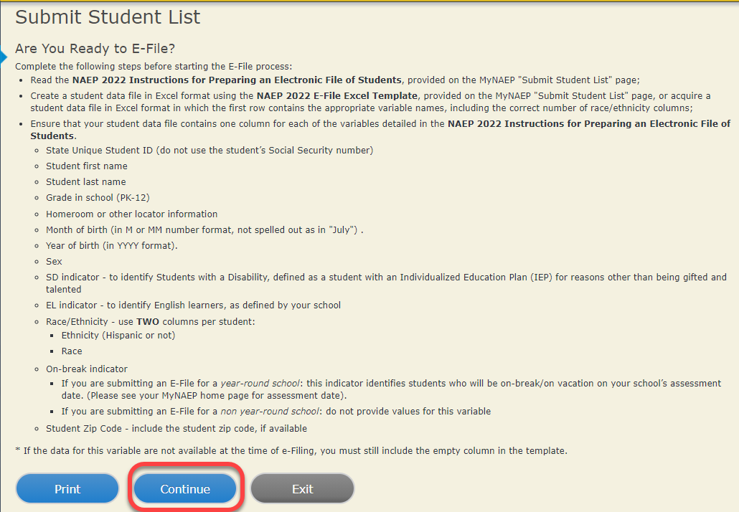

- Enter the required fields and then browse for the name of your file and select “Upload.”

Step 4 – Map Your Columns and Rows to NAEP Values
The field names used by your database system may not have the same names as the NAEP values. You will need to match the names of your columns to the names of the NAEP columns, and then, match row values to NAEP values.

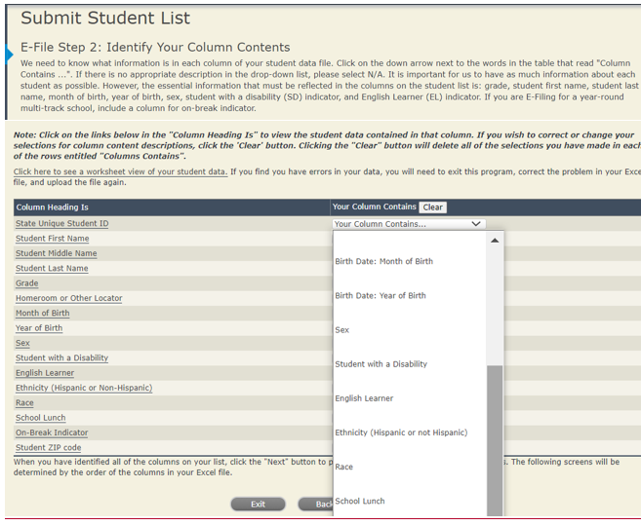

Shown below is an example of row mapping. You need to match the values in each of your columns to the NAEP codes (in drop-down). Once you map a value, select “Next” to move to the next value.

Step 5 – Review Warnings and Verify Data
When you finish row mapping, the E-Filing process will continue and a series of E-File checks will be run. These checks may produce warnings that you will need to review. If you find there are problems with your data, you can return to any mapping page to make any necessary changes. If your data are incorrect, you can choose “Start Over” and resubmit a new corrected file. If your data are correct, select “Continue” to move to the next screen.
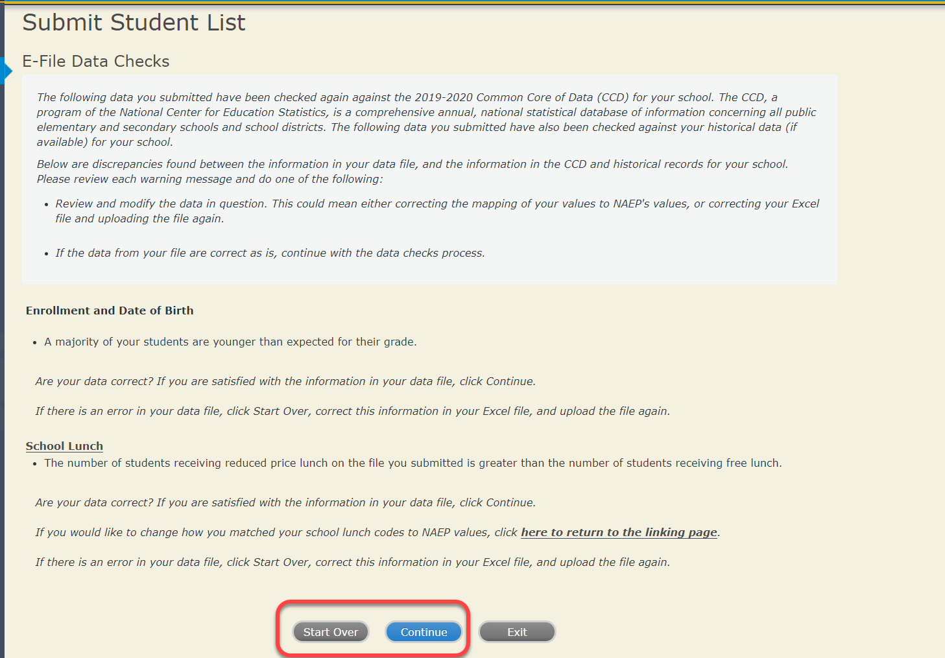
The next screen will show you a table that summarizes the data in your file. If you verify your data as correct, you need to select “Information is Correct” and then “Submit.”
If your data are incorrect, you should select “Information is Incorrect” or select “Back” and then “Start Over” to submit a new list.

If you need assistance, call the NAEP help desk at 1-800-283-6237.

Age 17 students, Race/Ethnicity – six columns

NAEP 2022 LTT 17
Instructions for Preparing and
Submitting an Electronic File of Students
(Six Columns Race/Ethnicity)
NAEP needs a complete list of students in the selected age group(s) at your school in order to draw a random sample of students to participate in the assessment. Your student data electronic file (E-File) must be submitted as a Microsoft Excel file.
We recommend that you create your student file using the NAEP E-File Excel Template, which is available on the MyNAEP website’s “Submit Student List” page. If necessary, you may alternatively provide an Excel file with the same column headers and data in a different order. If you cannot submit your student data in an Excel file, call the NAEP help desk at 1-800-283-6237.
Step 1 – The E-Filing Template
Download and review the E-Filing Template. Note the column headers (fields) that must be included in your student list. If you do not have data for a particular field, you may leave that column blank.
Step 2 – Compile Data for the Template
Prepare and submit a separate Excel file of all students in your school with birthdates between October 1, 2004 and September 30, 2005. Students may be in any grade, however, we expect most of the students to be in the following grades: 9, 10, 11, and 12.
- Include in the file data for all students in the age group, even those students who typically may be excluded from other testing programs, such as students with IEPs (SD) and English learners (EL). Make sure there are no duplicate students in your file.
- Make sure you provide information for all students in the sampled age group, including students participating in virtual/remote learning due to COVID-19.
- Also include students in the age group who were displaced from other locations due to hurricanes and other disasters.
- If this is a year-round school, include students who will be on break/on vacation on the scheduled assessment day along with all of the other students in the sampled age group. The NAEP E-File Excel Template contains an “On Break” column you will use to identify those students who will be on break/on vacation by filling in “Yes.” (If you are not using the template, be sure to create and provide data for an “On Break” column in your file.)
Your Excel file must contain the following data:
Excel Header/  Field Name | NAEP Values | Comments
State unique Student ID | N/A | If available; do not use the student’s Social Security number
Student First Name | N/A | Text; must be in its own column
Student Middle Name | N/A | Text; Middle Name is optional, but the column must be included in the Excel file
Student Last Name | N/A | Text; must be in its own column
Grade in School | Any | Use current year data
Homeroom or other Locator | N/A | If available; locator information is helpful in finding students and notifying them of the assessment
Month of Birth | M or MM (numeric format) | Numeric format; must be in its own column
Year of Birth | YYYY (numeric format)  The expected ranges for Year of Birth are listed below:  2004–2005 | Numeric format; must be in its own column
Sex | School-defined codes | Codes (numeric or text) for Male/Female
Ethnicity (Hispanic or not) | School-defined codes for  - Yes, Hispanic: A person of Mexican, Puerto Rican, Cuban, Central or South American, or other Spanish (but not Portuguese) culture of origin, regardless of race  - No, Not Hispanic  - Information unavailable at this time: If you currently do not have this information for one or more students, blank cells or an indicator such as “N/A” (Not Available) in the cell(s) can be mapped to this code to notify your NAEP representative of the need to collect the data at a later date. | Indicate all Race/Ethnicity categories that apply for each student, text or numeric
Race: White | - Yes, White: A person having origins in any of the original peoples of Europe, North Africa, or the Middle East  - No, not White  - Information unavailable at this time: If you currently do not have this information for one or more students, blank cells or an indicator such as “N/A” (Not Available) in the cell(s) can be mapped to this code to notify your NAEP representative of the need to collect the data at a later date. | Indicate all Race/Ethnicity categories that apply for each student, text or numeric
Race: Black or African American | - Yes, Black: A person having origins in any of the Black peoples of Africa  - No, not Black  - Information unavailable at this time: If you currently do not have this information for one or more students, blank cells or an indicator such as “N/A” (Not Available) in the cell(s) can be mapped to this code to notify your NAEP representative of the need to collect the data at a later date. | Indicate all Race/Ethnicity categories that apply for each student, text or numeric
Race: Asian | - Yes, Asian: A person having origins in any of the original peoples of the Far East, Southeast Asia, the Indian Subcontinent, including, for example, Cambodia, China, Japan, India, Korea, Malaysia, Pakistan, the Philippine Islands, Thailand, and Vietnam  - No, not Asian  - Information unavailable at this time: If you currently do not have this information for one or more students, blank cells or an indicator such as “N/A” (Not Available) in the cell(s) can be mapped to this code to notify your NAEP representative of the need to collect the data at a later date. | Indicate all Race/Ethnicity categories that apply for each student, text or numeric
Race: American Indian or Alaska Native | - Yes, American Indian or Alaska Native: A person having origins in any of the original peoples of North and South America (including Central America), and who maintains tribal affiliation or community attachment  - No, not American Indian or Alaska Native  - Information unavailable at this time: If you currently do not have this information for one or more students, blank cells or an indicator such as “N/A” (Not Available) in the cell(s) can be mapped to this code to notify your NAEP representative of the need to collect the data at a later date. | Indicate all Race/Ethnicity categories that apply for each student, text or numeric
Race: Native Hawaiian or Pacific Islander | - Yes, Native Hawaiian or Pacific Islander: A person having origins in any of the original people of Hawaii, Guam, Samoa or other Pacific Islands  - No, not Native Hawaiian or Pacific Islander  - Information unavailable at this time: If you currently do not have this information for one or more students, blank cells or an indicator such as “N/A” (Not Available) in the cell(s) can be mapped to this code to notify your NAEP representative of the need to collect the data at a later date. | Indicate all Race/Ethnicity categories that apply for each student, text or numeric
National School Lunch Program (NSLP) | School defined codes for  - Student not eligible to participate: Student is not eligible for free or reduced-price lunch  - Free lunch: Student is eligible for free lunch. Schools participating in Provisions 2 or 3 of the NSLP should code all students as “free lunch.”  - Reduced price lunch: Student is eligible for reduced-price lunch  - School not participating: School does not participate in the NSLP. When used, this code must be applied to all students.  - Information unavailable at this time: If you currently do not have this information for one or more students, blank cells or an indicator such as “N/A” (Not Available) in the cell(s) can be mapped to this code to notify your NAEP representative of the need to collect the data at a later date.  SPECIAL INSTRUCTIONS FOR CEP SCHOOLS: If your school participates in the Community Eligibility Provision (CEP), note that for NAEP, only students who are economically disadvantaged students can be classified as eligible for free or reduced-price lunch.  --------------------------------------------------------------------------------------------- | Use ONE code per student, text or numeric
CEP Direct Only
In CEP schools in our state, economically disadvantaged students are those who are directly certified through participation in assistance programs such as the Supplemental Nutrition Assistance Program (SNAP) and the Temporary Assistance for Needy Families (TANF).

Please code your students as follows:

Is the student economically disadvantaged? | How should student be coded on NAEP?
1. Yes | 1. Eligible for free or reduced-price lunch
2. No | 2. Student not eligible
3. Information missing | 3. Information unavailable

CEP Direct Certification Plus
In CEP schools in our state, economically disadvantaged students are identified in two ways: a) directly certified through participation in assistance programs such as the Supplemental Nutrition Assistance Program (SNAP) and the Temporary Assistance for Needy Families (TANF); b) through a household income survey.

Please code your students as follows:

Is the student economically disadvantaged? | How should student be coded on NAEP?
- Yes | 1. Eligible for free or reduced-price lunch
- No | 2. Student not eligible
- Information missing | 3. Information unavailable

CEP All
In our state, all students in CEP schools are considered economically disadvantaged.

Please code your students as follows:

Is the student economically disadvantaged? | How should student be coded on NAEP?
1. Yes | 1. Eligible for free lunch

Students with Disabilities (SD) | School-defined codes for  - Yes, IEP: Student has a formal Individualized Education Program (IEP), the student’s IEP is in progress, or the student has an equivalent classification for private schools. If some students have both an IEP and a 504 Plan, code these students as “Yes, IEP.”  - No, not SD: Student does not have an IEP. If students have a 504 Plan without an IEP, code these students as “No, not SD.”  - Information unavailable at this time: If you currently do not have this information for one or more students, blank cells or an indicator such as “N/A” (Not Available) in the cell(s) can be mapped to this code to notify your NAEP representative of the need to collect the data at a later date. | Use ONE code per student, text or numeric
English Learner (EL) | School-defined codes for  - Yes, EL  - No, Not EL  - No, Formerly EL: If a student has achieved full English proficiency within the previous 2 years and the state includes formerly EL students in its accountability reports, the student should be coded as “No, formerly EL.” Public schools, contact your NAEP State Coordinator if you have any questions about using this code.  - Information unavailable at this time: If you currently do not have this information for one or more students, blank cells or an indicator such as “N/A” (Not Available) in the cell(s) can be mapped to this code to notify your NAEP representative of the need to collect the data at a later date. | Use ONE code per student, text or numeric
On-Break Indicator | School-defined code | Only for year-round schools; column can be left off if school is not year-round
Student ZIP Code | Numeric only | If available; format can be five digits or five plus four

Tips for ensuring the E-File process goes smoothly:
- The NAEP E-File template should be used if possible. Please use it as is. Do not change the column headers. Student information must begin on the second row. There should be no empty rows between the headings and the student data or within the student data, and no headings within the data.
- If you are not able to use the NAEP E-File Excel Template (for example, because of the way your data system works), the columns in your Excel E-File should have the same, or similar, names but do not have to be in any particular order. You will be able to identify the contents of each column after you have submitted your file. (For example, you will be able to indicate that your column labeled “Gender” is what provides the NAEP “Sex” information, and your value of “1” is “Male” and a “2” is “Female,” or whatever the correct interpretation.)
- Be sure to give your file a unique, descriptive name. Select “File,” then “Save As,” and give it a name such as “Your School Name Age 17.xls.” Should you need to reference your file again, this will help you locate it after E-Filing.
- The first row of data in your file will be read as the column header unless you indicate otherwise on the E-Filing “Welcome” page. Each succeeding row will be considered a student record.
- If you merge or cut and paste data from another Excel file into the template, review the file afterward to be sure there are properly aligned student data in every row and there are no column headers or blank rows in the middle of the data.
- Be sure that your file contains only a heading row and student data, not notes or text in additional columns, or they will be read as data resulting in a warning or error message.
- There should be only one worksheet with data in the Excel file. If there are other worksheets, they must not contain any data.
Step 3 – E-File
Once your file is prepared and checked for accuracy and completeness, log in to the MyNAEP website and select “Submit Student List” from the left-hand menu.
- Select the “Start E-Filing Age 17” button.
- You will see a checklist on the next screen; please review it carefully to be sure your file is set up correctly and is ready to be submitted. Then select “Continue.”
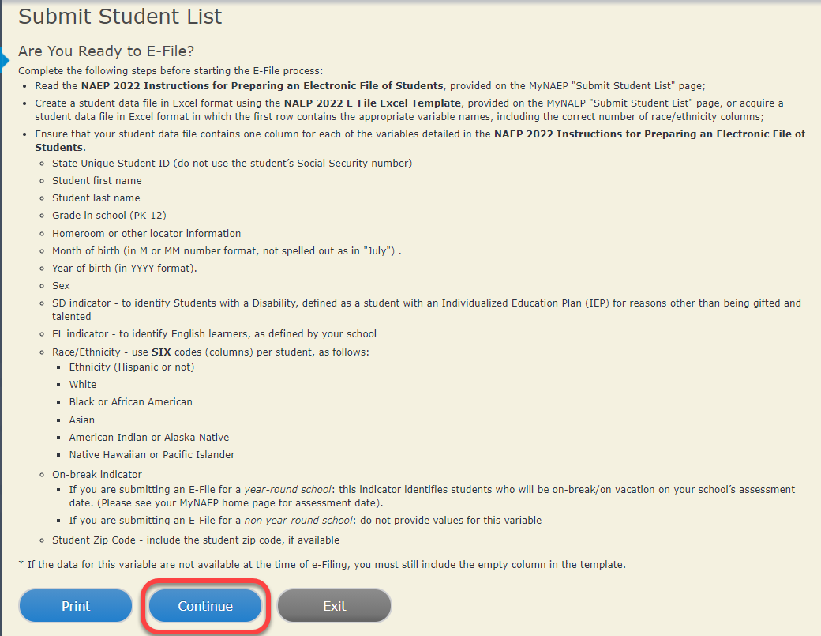
- Enter the required fields and then browse for the name of your file and select “Upload.”
Step 4 – Map Your Columns and Rows to NAEP Values
The field names used by your database system may not have the same names as the NAEP values. You will need to match the names of your columns to the names of the NAEP columns, and then, match row values to NAEP values.
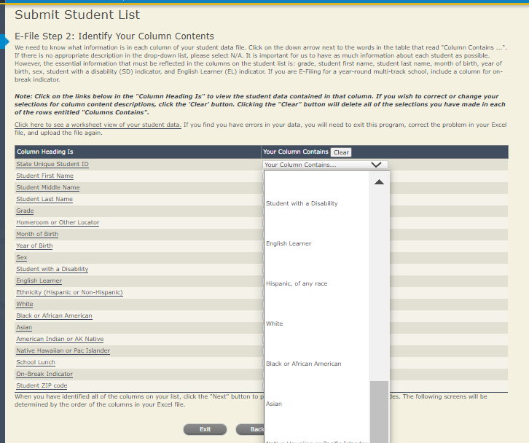

Shown below is an example of row mapping. You need to match the values in each of your columns to the NAEP codes (in drop-down). Once you map a value, select “Next” to move to the next value.

Step 5 – Review Warnings and Verify Data
When you finish row mapping, the E-Filing process will continue and a series of E-File checks will be run. These checks may produce warnings that you will need to review. If you find there are problems with your data, you can return to any mapping page to make any necessary changes. If your data are incorrect, you can choose “Start Over” and resubmit a new corrected file. If your data are correct, select “Continue” to move to the next screen.
The next screen will show you a table that summarizes the data in your file. If you verify your data as correct, you need to select “Information is Correct” and then “Submit.”
If your data are incorrect, you should select “Information is Incorrect” or select “Back” and then “Start Over” to submit a new list.

If you need assistance, call the NAEP help desk at 1-800-283-6237.

Age 9 students, Race/Ethnicity – one column

NAEP 2022 LTT 9
Instructions for Preparing and
Submitting an Electronic File of Students
(One Column Race/Ethnicity)
NAEP needs a complete list of students in the selected age group(s) at your school in order to draw a random sample of students to participate in the assessment. Your student data electronic file (E-File) must be submitted as a Microsoft Excel file.
We recommend that you create your student file using the NAEP E-File Excel Template, which is available on the MyNAEP website on the “Submit Student List” page. If necessary, you may alternatively provide an Excel file with the same column headers and data in a different order. If you cannot submit your student data in an Excel file, call the NAEP help desk at 1-800-283-6237.
Step 1 – The E-Filing Template
Download and review the E-Filing Template. Note the column headers (fields) that must be included in your student list. If you do not have data for a particular field, you may leave that column blank.
Step 2 – Compile Data for the Template
Prepare and submit a separate Excel file of all students in your school with birthdates between January 1, 2012 and December 31, 2012. Students may be in any grade; however, we expect most of the students to be in the following grades: 2, 3, 4, and 5.
- Include in the file data for all students in the age group, even those students who typically may be excluded from other testing programs, such as students with IEPs (SD) and English Learners (EL). Make sure there are no duplicate students in your file.
- Make sure you provide information for all students in the sampled age group, including students participating in virtual/remote learning due to COVID-19.
- Also include students in the age group who were displaced from other locations due to hurricanes and other disasters.
- If this is a year-round school, include students who will be on break/on vacation on the scheduled assessment day along with all of the other students in the sampled age group. The NAEP E-File Excel Template contains an “On Break” column you will use to identify those students who will be on break/on vacation by filling in “Yes.” (If you are not using the template, be sure to create and provide data for an “On Break” column in your file.)
Your Excel file must contain the following data:
Excel Header/  Field Name | NAEP Values | Comments
State unique Student ID | N/A | If available; do not use the student’s Social Security number
Student First Name | N/A | Text; must be in its own column
Student Middle Name | N/A | Text; Middle Name is optional, but the column must be included in the Excel file
Student Last Name | N/A | Text; must be in its own column
Grade in School | Any | Use current year data
Homeroom or other Locator | N/A | If available; locator information is helpful in finding students and notifying them of the assessment
Month of Birth | M or MM (numeric format) | Numeric format; must be in its own column
Year of Birth | YYYY (numeric format)  The expected ranges for Year of Birth are listed below:  2012 | Numeric format; must be in its own column
Sex | School-defined codes | Codes (numeric or text) for Male/Female
Race/Ethnicity – one column | School-defined codes for  - Hispanic, of any race: A person of Mexican, Puerto Rican, Cuban, Central or South American, or other Spanish (but not Portuguese) culture of origin, regardless of race  - White, not Hispanic: A person having origins in any of the original peoples of Europe (except Spain), North Africa, or the Middle East  - Black or African American, not Hispanic: A person having origins in any of the Black peoples of Africa  - Asian, not Hispanic: A person having origins in any of the original peoples of the Far East, Southeast Asia, the Indian Subcontinent, including, for example, Cambodia, China, Japan, India, Korea, Malaysia, Pakistan, the Philippine Islands, Thailand, and Vietnam  - American Indian or Alaska Native, not Hispanic: A person having origins in any of the original peoples of North and South America (including Central America), and who maintains tribal affiliation or community attachment  - Native Hawaiian or Pacific Islander, not Hispanic: A person having origins in any of the original people of Hawaii, Guam, Samoa or other Pacific Islands  - Two or More Races, not Hispanic: A person who identifies with two or more of the non-Hispanic categories above  - School does not collect this information: Available to nonpublic schools only. When used, this code must be applied to all students  - Information unavailable at this time: If you currently do not have this information for one or more students, blank cells or an indicator such as “N/A” (Not Available) in the cell(s) can be mapped to this code to notify your NAEP representative of the need to collect the data at a later date. | Use ONE code per student, text or numeric
National School Lunch Program (NSLP) | School defined codes for  - Student not eligible to participate: Student is not eligible for free or reduced-price lunch  - Free lunch: Student is eligible for free lunch. Schools participating in Provisions 2 or 3 of the NSLP should code all students as “free lunch.”  - Reduced-price lunch: Student is eligible for reduced-price lunch  - School not participating: School does not participate in the NSLP. When used, this code must be applied to all students.  - Information unavailable at this time: If you currently do not have this information for one or more students, blank cells or an indicator such as “N/A” (Not Available) in the cell(s) can be mapped to this code to notify your NAEP representative of the need to collect the data at a later date. | Use ONE code per student, text or numeric
SPECIAL INSTRUCTIONS FOR CEP SCHOOLS: If your school participates in the Community Eligibility Provision (CEP), note that for NAEP, only students who are economically disadvantaged students can be classified as eligible for free or reduced-price lunch.
---------------------------------------------------------------------------------------------
CEP Direct Only
In CEP schools in our state, economically disadvantaged students are those who are directly certified through participation in assistance programs such as the Supplemental Nutrition Assistance Program (SNAP) and the Temporary Assistance for Needy Families (TANF).

Please code your students as follows:

Is the student economically disadvantaged? | How should the student be coded on NAEP?
1. Yes | 1. Eligible for free or reduced-price lunch
- No | 2. Student not eligible
- Information missing | 3. Information unavailable
---------------------------------------------------------------------------------------------
CEP Direct Certification Plus
In CEP schools in our state, economically disadvantaged students are identified in two ways: (a) directly certified through participation in assistance programs such as the Supplemental Nutrition Assistance Program (SNAP) and the Temporary Assistance for Needy Families (TANF) and (b) through a household income survey.

Please code your students as follows:

Is the student economically disadvantaged? | How should the student be coded on NAEP?
1. Yes | 1. Eligible for free or reduced-price lunch
2. No | 2. Student not eligible
3. Information missing | 3. Information unavailable

CEP All
In our state, all students in CEP schools are considered economically disadvantaged.

Please code your students as follows:

Is the student economically disadvantaged? | How should the student be coded on NAEP?
1. Yes | 1. Eligible for free lunch

Students with Disabilities (SD) | School defined codes for  - Yes, IEP: Student has a formal Individualized Education Program (IEP), the student’s IEP is in progress, or the student has an equivalent classification for private schools. If some students have both an IEP and a 504 Plan, code these students as “Yes, IEP.”  - No, not SD: Student does not have an IEP. If students have a 504 Plan without an IEP, code these students as “No, not SD.”  - Information unavailable at this time: If you currently do not have this information for one or more students, blank cells or an indicator such as “N/A” (Not Available) in the cell(s) can be mapped to this code to notify your NAEP representative of the need to collect the data at a later date. | Use ONE code per student, text or numeric
English Learner (EL) | School-defined codes for  - Yes, EL  - No, Not EL  - No, Formerly EL: If a student has achieved full English proficiency within the previous 2 years and the state includes formerly EL students in its accountability reports, the student should be coded as “No, formerly EL.” Public schools, contact your NAEP State Coordinator if you have any questions about using this code.  - Information unavailable at this time: If you currently do not have this information for one or more students, blank cells or an indicator such as “N/A” (Not Available) in the cell(s) can be mapped to this code to notify your NAEP representative of the need to collect the data at a later date. | Use ONE code per student, text or numeric
On-Break Indicator | School-defined code | Only for year-round schools; column can be left off if school is not year-round
Student ZIP Code | Numeric only | If available; format can be 5 digits or 5 plus 4

Tips for ensuring the E-File process goes smoothly:
- The NAEP E-File template should be used, if possible. Please use it as is. Do not change the column headers. Student information must begin on the second row. There should be no empty rows between the headings and the student data or within the student data, and no headings within the data.
- If you are not able to use the NAEP E-File Excel Template (for example, because of the way your data system works), the columns in your Excel E-File should have the same, or similar, names but do not have to be in any particular order. You will be able to identify the contents of each column after you have submitted your file. (For example, you will be able to indicate that your column labeled “Gender” is what provides the NAEP “Sex” information, and your value of “1” is “Male” and a “2” is “Female,” or whatever the correct interpretation.)
- Be sure to give your file a unique, descriptive name. Select “File,” then “Save As,” and give it a name such as “Your School Name Age 9.xls.” Should you need to reference your file again, this will help you locate it after E-Filing.
- The first row of data in your file will be read as the column header unless you indicate otherwise on the E-Filing “Welcome” page. Each succeeding row will be considered a student record.
- If you merge or cut and paste data from another Excel file into the template, review the file afterward to be sure there are properly aligned student data in every row and there are no column headers or blank rows in the middle of the data.
- Be sure that your file contains only a heading row and student data, not notes or text in additional columns, or they will be read as data resulting in a warning or error message.
- There should be only one worksheet with data in the Excel file. If there are other worksheets, they must not contain any data.
Step 3 – E-File
Once your file is prepared and checked for accuracy and completeness, log in to the MyNAEP website and select “Submit Student List” from the left-hand menu.
- Select the “Start E-Filing Age 9” button.
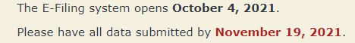
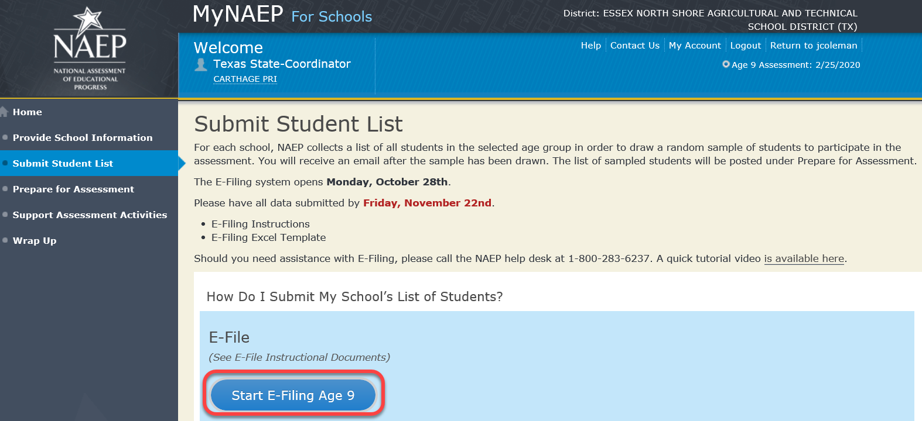
- You will see a checklist on the next screen; please review it carefully to be sure your file is set up correctly and is ready to be submitted. Then, select “Continue.”

- Enter the required fields, and then, browse for the name of your file and select “Upload.”
Step 4 – Map Your Columns and Rows to NAEP Values
The field names used by your database system may not have the same names as the NAEP values. You will need to match the names of your columns to the names of the NAEP columns and then match row values to NAEP values.ues.

Shown below is an example of row mapping. You need to match the values in each of your columns to the NAEP codes (in drop-down). Once you map a value, select “Next” to move to the next value.
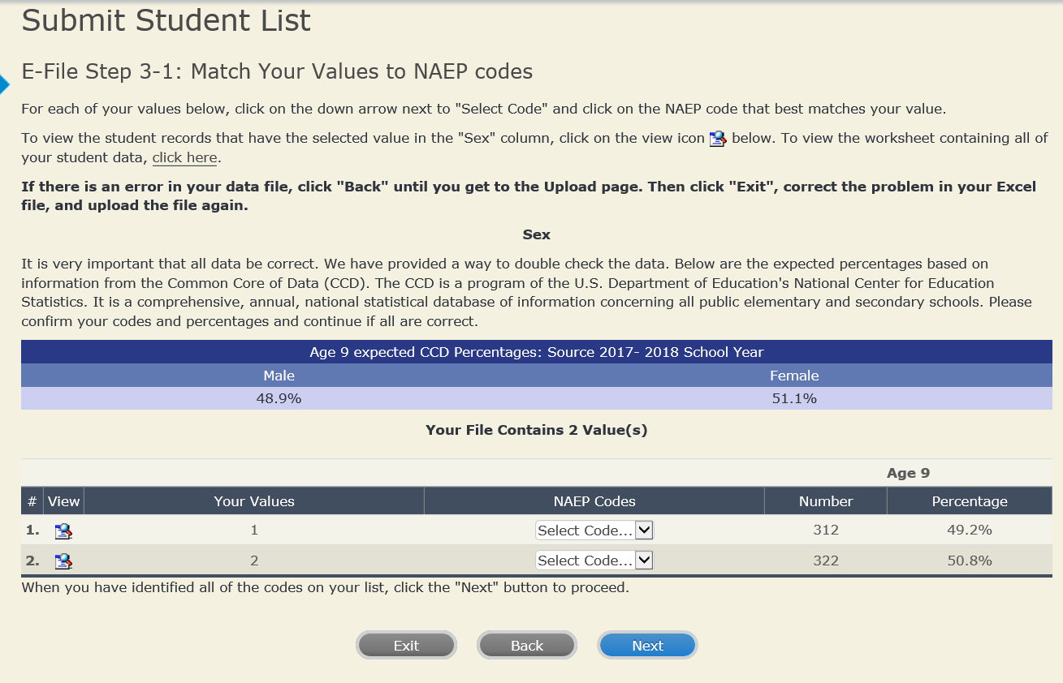

Step 5 – Review Warnings and Verify Data

When you finish row mapping, the E-Filing process will continue and a series of E-File checks will be run. These checks may produce warnings that you will need to review. If you find there are problems with your data, you can return to any mapping page to make any necessary changes. If your data are incorrect, you can choose “Start Over” and resubmit a new corrected file. If your data are correct, select “Continue” to move to the next screen.
The next screen will show you a table that summarizes the data in your file. If you verify your data as correct, you need to select “Information is Correct” and then “Submit.”
If your data are incorrect, you should select “Information is Incorrect” or select “Back” and then “Start Over” to submit a new list.
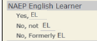
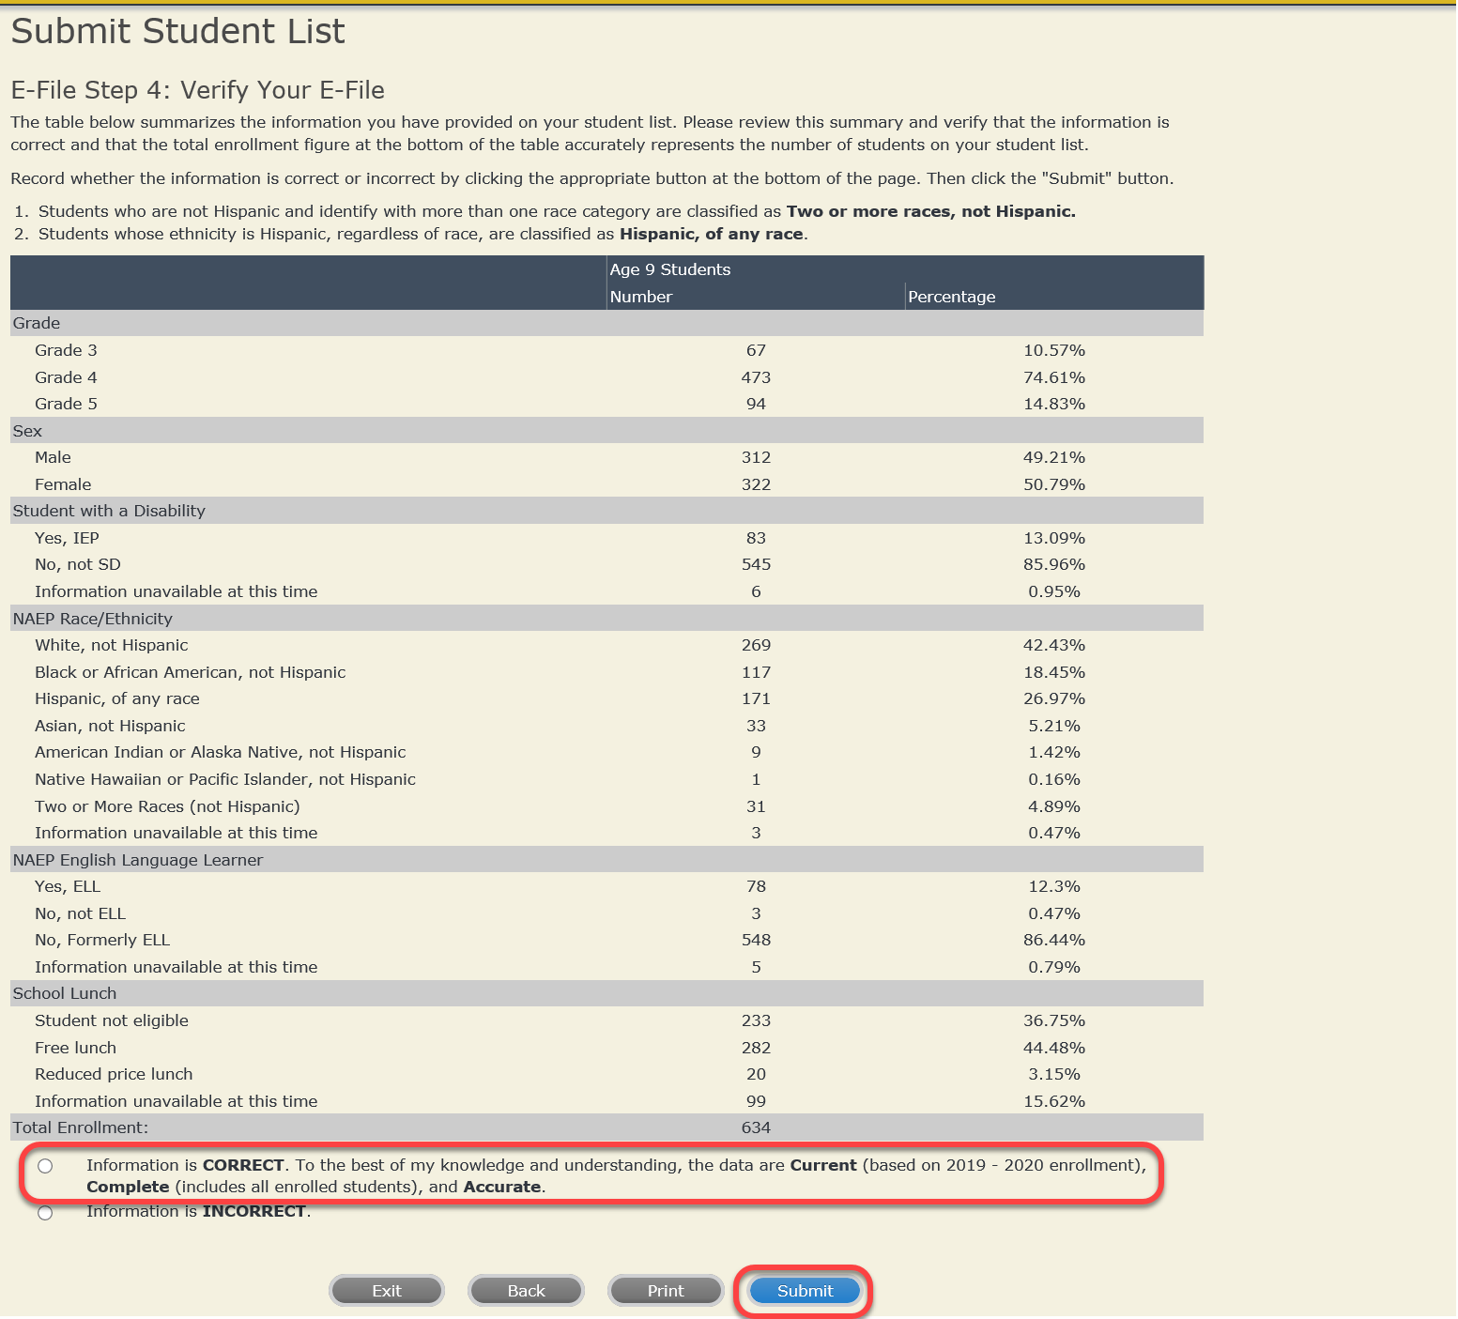

If you need assistance, call the NAEP help desk at 1-800-283-6237.

Age 9 students, Race/Ethnicity – two columns

NAEP 2022 LTT 9
Instructions for Preparing and
Submitting an Electronic File of Students
(Two Columns Race/Ethnicity)
NAEP needs a complete list of students in the selected age group(s) at your school in order to draw a random sample of students to participate in the assessment. Your student data electronic file (E-File) must be submitted as a Microsoft Excel file.
We recommend that you create your student file using the NAEP E-File Excel Template, which is available on the MyNAEP website on the “Submit Student List” page. If necessary, you may alternatively provide an Excel file with the same column headers and data in a different order. If you cannot submit your student data in an Excel file, call the NAEP help desk at 1-800-283-6237.
Step 1 – The E-Filing Template
Download and review the E-Filing Template. Note the column headers (fields) that must be included in your student list. If you do not have data for a particular field, you may leave the column blank.
Step 2 – Compile Data for the Template
Prepare and submit a separate Excel file of all students in your school with birthdates between January 1, 2012 and December 31, 2012. Students may be in any grade; however, we expect most of the students to be in the following grades: 2, 3, 4, and 5.
- Include in the file data for all students in the age group, even those students who typically may be excluded from other testing programs, such as students with IEPs (SD) and English Learners (EL). Make sure there are no duplicate students in your file.
- Make sure you provide information for all students in the sampled age group, including students participating in virtual/remote learning due to COVID-19.
- Also include students in the age group who were displaced from other locations due to hurricanes and other disasters.
- If this is a year-round school, include students who will be on break/on vacation on the scheduled assessment day along with all of the other students in the sampled age group. The NAEP E-File Excel Template contains an “On Break” column you will use to identify those students who will be on break/on vacation by filling in “Yes.” (If you are not using the template, be sure to create and provide data for an “On Break” column in your file.)
Your Excel file must contain the following data:
Excel Header/  Field Name | NAEP Values | Comments
State unique Student ID | N/A | If available; do not use the student’s Social Security number
Student First Name | N/A | Text; must be in its own column
Student Middle Name | N/A | Text; Middle Name is optional, but the column must be included in the Excel file
Student Last Name | N/A | Text; must be in its own column
Grade in School | Any | Use current year data
Homeroom or other Locator | N/A | If available; locator information is helpful in finding students and notifying them of the assessment
Month of Birth | M or MM (numeric format) | Numeric format; must be in its own column
Year of Birth | YYYY (numeric format)  The expected ranges for Year of Birth are listed below:  2012 | Numeric format; must be in its own column
Sex | School-defined codes | Codes (numeric or text) for Male/Female
Ethnicity (Hispanic or not) | School-defined codes for  - Yes, Hispanic: A person of Mexican, Puerto Rican, Cuban, Central or South American, or other Spanish (but not Portuguese) culture of origin, regardless of race  - No, Not Hispanic  - Information unavailable at this time: If you currently do not have this information for one or more students, blank cells or an indicator such as “N/A” (Not Available) in the cell(s) can be mapped to this code to notify your NAEP representative of the need to collect the data at a later date. | Use ONE code per student, text or numeric
Race | School-defined codes for  - White: A person having origins in any of the original peoples of Europe, North Africa, or the Middle East  - Black or African American: A person having origins in any of the Black peoples of Africa  - Asian: A person having origins in any of the original peoples of the Far East, Southeast Asia, the Indian Subcontinent, including, for example, Cambodia, China, Japan, India, Korea, Malaysia, Pakistan, the Philippine Islands, Thailand, and Vietnam  - American Indian or Alaska Native: A person having origins in any of the original peoples of North and South America (including Central America), and who maintains tribal affiliation or community attachment  - Native Hawaiian or Pacific Islander: A person having origins in any of the original people of Hawaii, Guam, Samoa or other Pacific Islands  - Two or More Races: A person who identifies with two or more of the race categories above  - School does not collect this information: Available to nonpublic schools only. When used, this code must be applied to all students.  - Information unavailable at this time: If you currently do not have this information for one or more students, blank cells or an indicator such as “N/A” (Not Available) in the cell(s) can be mapped to this code to notify your NAEP representative of the need to collect the data at a later date. | Use ONE code per student, text or numeric
National School Lunch Program (NSLP) | School defined codes for  - Student not eligible to participate: Student is not eligible for free or reduced-price lunch  - Free lunch: Student is eligible for free lunch. Schools participating in Provisions 2 or 3 of the NSLP should code all students as “free lunch.”  - Reduced-price lunch: Student is eligible for reduced-price lunch  - School not participating: School does not participate in the NSLP. When used, this code must be applied to all students.  - Information unavailable at this time: If you currently do not have this information for one or more students, blank cells or an indicator such as “N/A” (Not Available) in the cell(s) can be mapped to this code to notify your NAEP representative of the need to collect the data at a later date. | Use ONE code per student, text or numeric
SPECIAL INSTRUCTIONS FOR CEP SCHOOLS: If your school participates in the Community Eligibility Provision (CEP), note that for NAEP, only students who are economically disadvantaged students can be classified as eligible for free or reduced-price lunch.
---------------------------------------------------------------------------------------------
CEP Direct Only
In CEP schools in our state, economically disadvantaged students are those who are directly certified through participation in assistance programs such as the Supplemental Nutrition Assistance Program (SNAP) and the Temporary Assistance for Needy Families (TANF).

Please code your students as follows:

Is the student economically disadvantaged? | How should the student be coded on NAEP?
1. Yes | 1. Eligible for free or reduced-price lunch
2. No | 2. Student not eligible
3. Information missing | 3. Information unavailable
---------------------------------------------------------------------------------------------
CEP Direct Certification Plus
In CEP schools in our state, economically disadvantaged students are identified in two ways: (a) directly certified through participation in assistance programs such as the Supplemental Nutrition Assistance Program (SNAP) and the Temporary Assistance for Needy Families (TANF) and (b) through a household income survey.

Please code your students as follows:

Is the student economically disadvantaged? | How should the student be coded on NAEP?
1. Yes | 1. Eligible for free or reduced price lunch
2. No | 2. Student not eligible
3. Information missing | 3. Information unavailable

CEP All
In our state, all students in CEP schools are considered economically disadvantaged.

Please code your students as follows:

Is the student economically disadvantaged? | How should the student be coded on NAEP?
1. Yes | 1. Eligible for free lunch

Students with Disabilities (SD) | School-defined codes for  - Yes, IEP: Student has a formal Individualized Education Program (IEP), the student’s IEP is in progress, or the student has an equivalent classification for private schools. If some students have both an IEP and a 504 Plan, code these students as “Yes, IEP.”  - No, not SD: Student does not have an IEP. If students have a 504 Plan without an IEP, code these students as “No, not SD.”  - Information unavailable at this time: If you currently do not have this information for one or more students, blank cells or an indicator such as “N/A” (Not Available) in the cell(s) can be mapped to this code to notify your NAEP representative of the need to collect the data at a later date. | Use ONE code per student, text or numeric
English Learner (EL) | School-defined codes for  - Yes, EL  - No, Not EL  - No, Formerly EL: If a student has achieved full English proficiency within the previous 2 years and the state includes formerly EL students in its accountability reports, the student should be coded as “No, formerly EL.” Public schools, contact your NAEP State Coordinator if you have any questions about using this code.  - Information unavailable at this time: If you currently do not have this information for one or more students, blank cells or an indicator such as “N/A” (Not Available) in the cell(s) can be mapped to this code to notify your NAEP representative of the need to collect the data at a later date. | Use ONE code per student, text or numeric
On-Break Indicator | School-defined code | Only for year-round schools; column can be left off if school is not year-round
Student ZIP Code | Numeric only | If available; format can be 5 digits or 5 plus 4

Tips for ensuring the E-File process goes smoothly:
- The NAEP E-File template should be used, if possible. Please use it as is. Do not change the column headers. Student information must begin on the second row. There should be no empty rows between the headings and the student data or within the student data, and no headings within the data.
- If you are not able to use the NAEP E-File Excel Template (for example, because of the way your data system works), the columns in your Excel E-File should have the same, or similar, names but do not have to be in any particular order. You will be able to identify the contents of each column after you have submitted your file. (For example, you will be able to indicate that your column labeled “Gender” is what provides the NAEP “Sex” information, and your value of “1” is “Male” and a “2” is “Female,” or whatever the correct interpretation.)
- Be sure to give your file a unique, descriptive name. Select “File,” then “Save As,” and give it a name such as “Your School Name Age 9.xls.” Should you need to reference your file again, this will help you locate it after E-Filing.
- The first row of data in your file will be read as the column header unless you indicate otherwise on the E-Filing “Welcome” page. Each succeeding row will be considered a student record.
- If you merge or cut and paste data from another Excel file into the template, review the file afterward to be sure there are properly aligned student data in every row and there are no column headers or blank rows in the middle of the data.
- Be sure that your file contains only a heading row and student data, not notes or text in additional columns, or they will be read as data resulting in a warning or error message.
- There should be only one worksheet with data in the Excel file. If there are other worksheets, they must not contain any data.

Step 3 – E-File
Once your file is prepared and checked for accuracy and completeness, log in to the MyNAEP website and select “Submit Student List” from the left-hand menu.
- Select the “Start E-Filing Age 9” button.
- You will see a checklist on the next screen; please review it carefully to be sure your file is set up correctly and is ready to be submitted. Then, select “Continue.”

- Enter the required fields, and then, browse for the name of your file and select “Upload.”
Step 4 – Map Your Columns and Rows to NAEP Values
The field names used by your database system may not have the same names as the NAEP values. You will need to match the names of your columns to the names of the NAEP columns and then match row values to NAEP values.
Shown below is an example of row mapping. You need to match the values in each of your columns to the NAEP codes (in drop-down). Once you map a value, select “Next” to move to the next value.

Step 5 – Review Warnings and Verify Data

When you finish row mapping, the E-Filing process will continue and a series of E-File checks will be run. These checks may produce warnings that you will need to review. If you find there are problems with your data, you can return to any mapping page to make any necessary changes. If your data are incorrect, you can choose “Start Over” and resubmit a new corrected file. If your data are correct, select “Continue” to move to the next screen.
The next screen will show you a table that summarizes the data in your file. If you verify your data as correct, you need to select “Information is Correct” and then “Submit.”
If your data are incorrect, you should select “Information is Incorrect” or select “Back” and then “Start Over” to submit a new list.

If you need assistance, call the NAEP help desk at 1-800-283-6237.

Age 9 students, Race/Ethnicity – six columns

NAEP 2022 LTT 9
Instructions for Preparing and
Submitting an Electronic File of Students
(Six Columns Race/Ethnicity)
NAEP needs a complete list of students in the selected age group(s) at your school in order to draw a random sample of students to participate in the assessment. Your student data electronic file (E-File) must be submitted as a Microsoft Excel file.
We recommend that you create your student file using the NAEP E-File Excel Template, which is available on the MyNAEP website on the “Submit Student List” page. If necessary, you may alternatively provide an Excel file with the same column headers and data in a different order. If you cannot submit your student data in an Excel file, call the NAEP help desk at 1-800-283-6237.
Step 1 – The E-Filing Template
Download and review the E-Filing Template. Note the column headers (fields) that must be included in your student list. If you do not have data for a particular field, you may leave the column blank.
Step 2 – Compile Data for the Template
Prepare and submit a separate Excel file of all students in your school with birthdates between January 1, 2012 and December 31, 2012. Students may be in any grade; however, we expect most of the students to be in the following grades: 2, 3, 4, and 5.
- Include in the file data for all students in the age group, even those students who typically may be excluded from other testing programs, such as students with IEPs (SD) and English Learners (EL). Make sure there are no duplicate students in your file.
- Make sure you provide information for all students in the age group, including students participating in virtual/remote learning due to COVID-19.
- Also include students in the age group who were displaced from other locations due to hurricanes and other disasters.
- If this is a year-round school, include students who will be on break/on vacation on the scheduled assessment day along with all of the other students in the sampled age group. The NAEP E-File Excel Template contains an “On Break” column you will use to identify those students who will be on break/on vacation by filling in “Yes.” (If you are not using the template, be sure to create and provide data for an “On Break” column in your file.)
Your Excel file must contain the following data:
Excel Header/  Field Name | NAEP Values | Comments
State unique Student ID | N/A | If available; do not use the student’s Social Security number
Student First Name | N/A | Text; must be in its own column
Student Middle Name | N/A | Text; Middle Name is optional, but the column must be included in the Excel file
Student Last Name | N/A | Text; must be in its own column
Grade in School | Any | Use current year data
Homeroom or other Locator | N/A | If available; locator information is helpful in finding students and notifying them of the assessment
Month of Birth | M or MM (numeric format) | Numeric format; must be in its own column
Year of Birth | YYYY (numeric format)  The expected ranges for Year of Birth are listed below:  2012 | Numeric format; must be in its own column
Sex | School-defined codes | Codes (numeric or text) for Male/Female
Ethnicity (Hispanic or not) | School-defined codes for  - Yes, Hispanic: A person of Mexican, Puerto Rican, Cuban, Central or South American, or other Spanish (but not Portuguese) culture of origin, regardless of race  - No, Not Hispanic  - Information unavailable at this time: If you currently do not have this information for one or more students, blank cells or an indicator such as “N/A” (Not Available) in the cell(s) can be mapped to this code to notify your NAEP representative of the need to collect the data at a later date. | Indicate all Race/Ethnicity categories that apply for each student, text or numeric
Race: White | - Yes, White: A person having origins in any of the original peoples of Europe, North Africa, or the Middle East  - No, not White  - Information unavailable at this time: If you currently do not have this information for one or more students, blank cells or an indicator such as “N/A” (Not Available) in the cell(s) can be mapped to this code to notify your NAEP representative of the need to collect the data at a later date. | Indicate all Race/Ethnicity categories that apply for each student, text or numeric
Race: Black or African American | - Yes, Black: A person having origins in any of the Black peoples of Africa  - No, not Black  - Information unavailable at this time: If you currently do not have this information for one or more students, blank cells or an indicator such as “N/A” (Not Available) in the cell(s) can be mapped to this code to notify your NAEP representative of the need to collect the data at a later date. | Indicate all Race/Ethnicity categories that apply for each student, text or numeric
Race: Asian | - Yes, Asian: A person having origins in any of the original peoples of the Far East, Southeast Asia, the Indian Subcontinent, including, for example, Cambodia, China, Japan, India, Korea, Malaysia, Pakistan, the Philippine Islands, Thailand, and Vietnam  - No, not Asian  - Information unavailable at this time: If you currently do not have this information for one or more students, blank cells or an indicator such as “N/A” (Not Available) in the cell(s) can be mapped to this code to notify your NAEP representative of the need to collect the data at a later date. | Indicate all Race/Ethnicity categories that apply for each student, text or numeric
Race: American Indian or Alaska Native | - Yes, American Indian or Alaska Native: A person having origins in any of the original peoples of North and South America (including Central America), and who maintains tribal affiliation or community attachment  - No, not American Indian or Alaska Native  - Information unavailable at this time: If you currently do not have this information for one or more students, blank cells or an indicator such as “N/A” (Not Available) in the cell(s) can be mapped to this code to notify your NAEP representative of the need to collect the data at a later date. | Indicate all Race/Ethnicity categories that apply for each student, text or numeric
Race: Native Hawaiian or Pacific Islander | - Yes, Native Hawaiian or Pacific Islander: A person having origins in any of the original people of Hawaii, Guam, Samoa or other Pacific Islands  - No, not Native Hawaiian or Pacific Islander  - Information unavailable at this time: If you currently do not have this information for one or more students, blank cells or an indicator such as “N/A” (Not Available) in the cell(s) can be mapped to this code to notify your NAEP representative of the need to collect the data at a later date. | Indicate all Race/Ethnicity categories that apply for each student, text or numeric
National School Lunch Program (NSLP) | School defined codes for  - Student not eligible to participate: Student is not eligible for free or reduced-price lunch  - Free lunch: Student is eligible for free lunch. Schools participating in Provisions 2 or 3 of the NSLP should code all students as “free lunch.”  - Reduced-price lunch: Student is eligible for reduced-price lunch  - School not participating: School does not participate in the NSLP. When used, this code must be applied to all students.  - Information unavailable at this time: If you currently do not have this information for one or more students, blank cells or an indicator such as “N/A” (Not Available) in the cell(s) can be mapped to this code to notify your NAEP representative of the need to collect the data at a later date.  SPECIAL INSTRUCTIONS FOR CEP SCHOOLS: If your school participates in the Community Eligibility Provision (CEP), note that for NAEP, only students who are economically disadvantaged students can be classified as eligible for free or reduced-price lunch.  --------------------------------------------------------------------------------------------- | Use ONE code per student, text or numeric
CEP Direct Only
In CEP schools in our state, economically disadvantaged students are those who are directly certified through participation in assistance programs such as the Supplemental Nutrition Assistance Program (SNAP) and the Temporary Assistance for Needy Families (TANF).

Please code your students as follows:

Is the student economically disadvantaged? | How should the student be coded on NAEP?
1. Yes | 1. Eligible for free or reduced-price lunch
2. No | 2. Student not eligible
3. Information missing | 3. Information unavailable

CEP Direct Certification Plus
In CEP schools in our state, economically disadvantaged students are identified in two ways: (a) directly certified through participation in assistance programs such as the Supplemental Nutrition Assistance Program (SNAP) and the Temporary Assistance for Needy Families (TANF) and (b) through a household income survey.

Please code your students as follows:

Is the student economically disadvantaged? | How should the student be coded on NAEP?
- Yes | 1. Eligible for free or reduced-price lunch
- No | 2. Student not eligible
- Information missing | 3. Information unavailable
---------------------------------------------------------------------------------------------
CEP All
In our state, all students in CEP schools are considered economically disadvantaged.

Please code your students as follows:

Is the student economically disadvantaged? | How should the student be coded on NAEP?
1. Yes | 1. Eligible for free lunch

Students with Disabilities (SD) | School-defined codes for  - Yes, IEP: Student has a formal Individualized Education Program (IEP), the student’s IEP is in progress, or the student has an equivalent classification for private schools. If some students have both an IEP and a 504 Plan, code these students as “Yes, IEP.”  - No, not SD: Student does not have an IEP. If students have a 504 Plan without an IEP, code these students as “No, not SD.”  - Information unavailable at this time: If you currently do not have this information for one or more students, blank cells or an indicator such as “N/A” (Not Available) in the cell(s) can be mapped to this code to notify your NAEP representative of the need to collect the data at a later date. | Use ONE code per student, text or numeric
English Learner (EL) | School-defined codes for  - Yes, EL  - No, Not EL  - No, Formerly EL: If a student has achieved full English proficiency within the previous 2 years and the state includes formerly EL students in its accountability reports, the student should be coded as “No, formerly EL.” Public schools, contact your NAEP State Coordinator if you have any questions about using this code.  - Information unavailable at this time: If you currently do not have this information for one or more students, blank cells or an indicator such as “N/A” (Not Available) in the cell(s) can be mapped to this code to notify your NAEP representative of the need to collect the data at a later date. | Use ONE code per student, text or numeric
On-Break Indicator | School-defined code | Only for year-round schools; column can be left off if school is not year-round
Student ZIP Code | Numeric only | If available; format can be 5 digits or 5 plus 4

Tips for ensuring the E-File process goes smoothly:
- The NAEP E-File template should be used, if possible. Please use it as is. Do not change the column headers. Student information must begin on the second row. There should be no empty rows between the headings and the student data or within the student data, and no headings within the data.
- If you are not able to use the NAEP E-File Excel Template (for example, because of the way your data system works), the columns in your Excel E-File should have the same, or similar, names but do not have to be in any particular order. You will be able to identify the contents of each column after you have submitted your file. (For example, you will be able to indicate that your column labeled “Gender” is what provides the NAEP “Sex” information, and your value of “1” is “Male” and a “2” is “Female,” or whatever the correct interpretation.)
- Be sure to give your file a unique, descriptive name. Select “File,” then “Save As,” and give it a name such as “Your School Name Age 9.xls.” Should you need to reference your file again, this will help you locate it after E-Filing.
- The first row of data in your file will be read as the column header unless you indicate otherwise on the E-Filing “Welcome” page. Each succeeding row will be considered a student record.
- If you merge or cut and paste data from another Excel file into the template, review the file afterward to be sure there are properly aligned student data in every row and there are no column headers or blank rows in the middle of the data.
- Be sure that your file contains only a heading row and student data, not notes or text in additional columns, or they will be read as data resulting in a warning or error message.
- There should be only one worksheet with data in the Excel file. If there are other worksheets, they must not contain any data.
Step 3 – E-File
Once your file is prepared and checked for accuracy and completeness, log in to the MyNAEP website and select “Submit Student List” from the left-hand menu.
- Select the “Start E-Filing Age 9” button.
- You will see a checklist on the next screen; please review it carefully to be sure your file is set up correctly and is ready to be submitted. Then, select “Continue.”
- Enter the required fields, and then, browse for the name of your file and select “Upload.”

Step 4 – Map Your Columns and Rows to NAEP Values
The field names used by your database system may not have the same names as the NAEP values. You will need to match the names of your columns to the names of the NAEP columns and then match row values to NAEP values.

Shown below is an example of row mapping. You need to match the values in each of your columns to the NAEP codes (in drop-down). Once you map a value, select “Next” to move to the next value.

Step 5 – Review Warnings and Verify Data
When you finish row mapping, the E-Filing process will continue and a series of E-File checks will be run. These checks may produce warnings that you will need to review. If you find there are problems with your data, you can return to any mapping page to make any necessary changes. If your data are incorrect, you can choose “Start Over” and resubmit a new corrected file. If your data are correct, select “Continue” to move to the next screen.
The next screen will show you a table that summarizes the data in your file. If you verify your data as correct, you need to select “Information is Correct” and then “Submit.”
If your data are incorrect, you should select “Information is Incorrect” or select “Back” and then “Start Over” to submit a new list.

If you need assistance, call the NAEP help desk at 1-800-283-6237.

In year-round schools, students attend classes throughout the 12 calendar months, unlike traditional schools that follow the 9-month calendar. However, at any one time during the year a percentage (e.g., 25 percent) of the students will be on break or on vacation.
If it is not possible to distinguish between “free” and “reduced-price” for some students, code these students as eligible for free lunch.
In year-round schools, students attend classes throughout the 12 calendar months unlike traditional schools that follow the 9-month calendar. However, at any one time during the year a percentage (e.g., 25 percent) of the students will be on break or on vacation.
If it is not possible to distinguish between “free” and “reduced-price” for some students, code these students as eligible for free lunch.
In year-round schools, students attend classes throughout the 12 calendar months unlike traditional schools that follow the 9-month calendar. However, at any one time during the year a percentage (e.g., 25 percent) of the students will be on break or on vacation.
If it is not possible to distinguish between “free” and “reduced-price” for some students, code these students as eligible for free lunch
In year-round schools, students attend classes throughout the 12 calendar months, unlike traditional schools that follow the 9-month calendar. However, at any one time during the year, a percentage (e.g., 25 percent) of the students will be on break or on vacation.
If it is not possible to distinguish between “free” and “reduced-price” for some students, code these students as eligible for free lunch.
In year-round schools, students attend classes throughout the 12 calendar months unlike traditional schools that follow the 9-month calendar. However, at any one time during the year, a percentage (e.g., 25 percent) of the students will be on break or on vacation.
If it is not possible to distinguish between “free” and “reduced-price” for some students, code these students as eligible for free lunch.
In year-round schools, students attend classes throughout the 12 calendar months unlike traditional schools that follow the 9-month calendar. However, at any one time during the year, a percentage (e.g., 25 percent) of the students will be on break or on vacation.
If it is not possible to distinguish between “free” and “reduced-price” for some students, code these students as eligible for free lunch.

