**NASA Integrated Service Management System (NISM) Customer Satisfaction Survey**

**Email Subject:** NISM Survey for #Service_Request_ID# (#Service_Request_Summary#)

**Email Body:**

Please take a moment to complete a NASA Integrated Service Management (NISM) customer survey for your request #Service Request ID# . We value your feedback and are constantly looking for ways to improve our service to you. Click on the link above or copy and paste it into your Internet browser to access the survey.

Summary: #Service Request Summary of service call#

To access your request please login to NISM <https://nism.ndc.nasa.gov> with your NASA credentials.

Please do not reply to this message. This mailbox is not monitored.  If you have problems please contact the NASA Information Support Center (NISC) at [MSFC-Helpdesk@mail.nasa.gov](mailto:MSFC-Helpdesk@mail.nasa.gov) or 256-544-1771.

PLEASE NOTE:  Access to the survey is limited to the NASA network.  If you are unable to access and would like to provide feedback, please contact the NISC @ 256-544-HELP option 0.

***

<https://nism.ndc.nasa.gov/arsys/servlet/ViewFormServlet?form=SRM%3aSurvey&server=mcsitsm&eid=SRVXXXXXXXXXXXX>

When the user clicks the link to fill out the survey, they are presented with: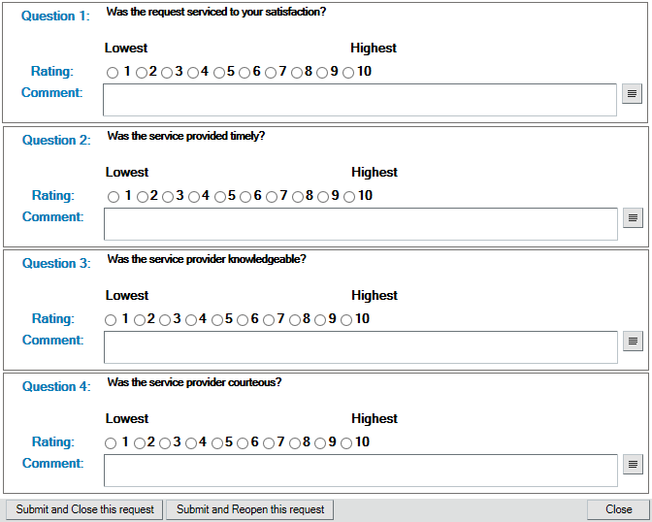

***Paperwork Reduction Act Statement*** *– This information collection meets the requirements of 44 U.S.C. § 3507, as amended by section 2 of the Paperwork Reduction Act of 1995. You do not need to answer these questions unless we display a valid Office of Management and Budget control number. The OMB control number for this information collection is 2700-0153 and it expires on 07/31/2018. We estimate that it will take about 1 minute to read the instructions, gather the facts, and answer the questions. You may send comments on our time estimate above to* [*MSFC-CUSTOMER-CARE@mail.nasa.gov*](mailto:MSFC-CUSTOMER-CARE@mail.nasa.gov)*. Send only comments relating to our time estimate to this address.*