**U.S. Bureau of Labor Statistics**

**International Price Program**

Import/Export Price Survey website

**Login page**

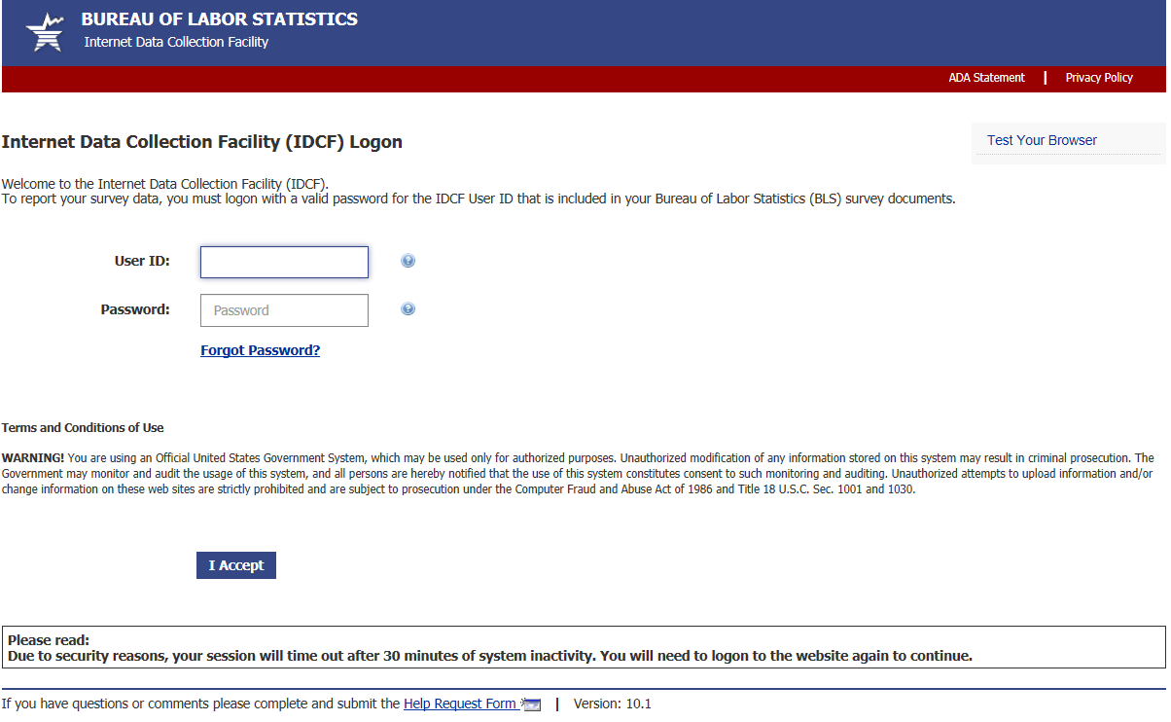

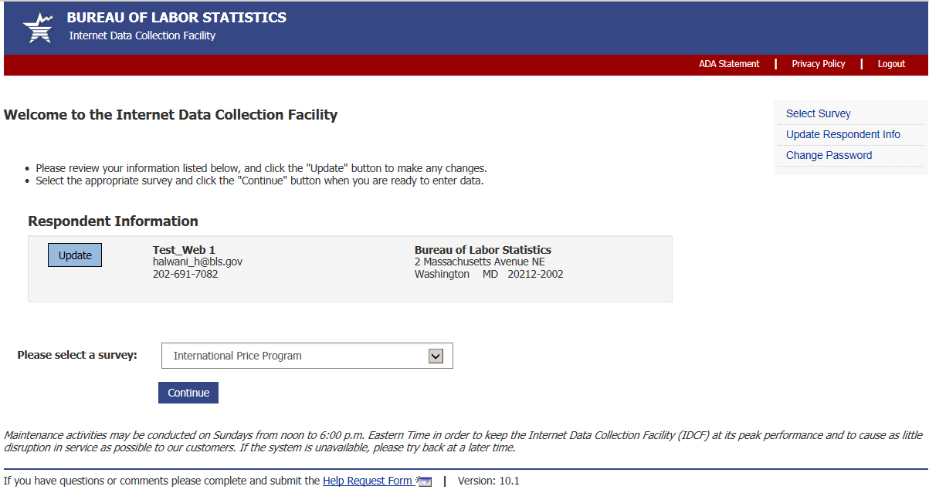

**Welcome Screen**

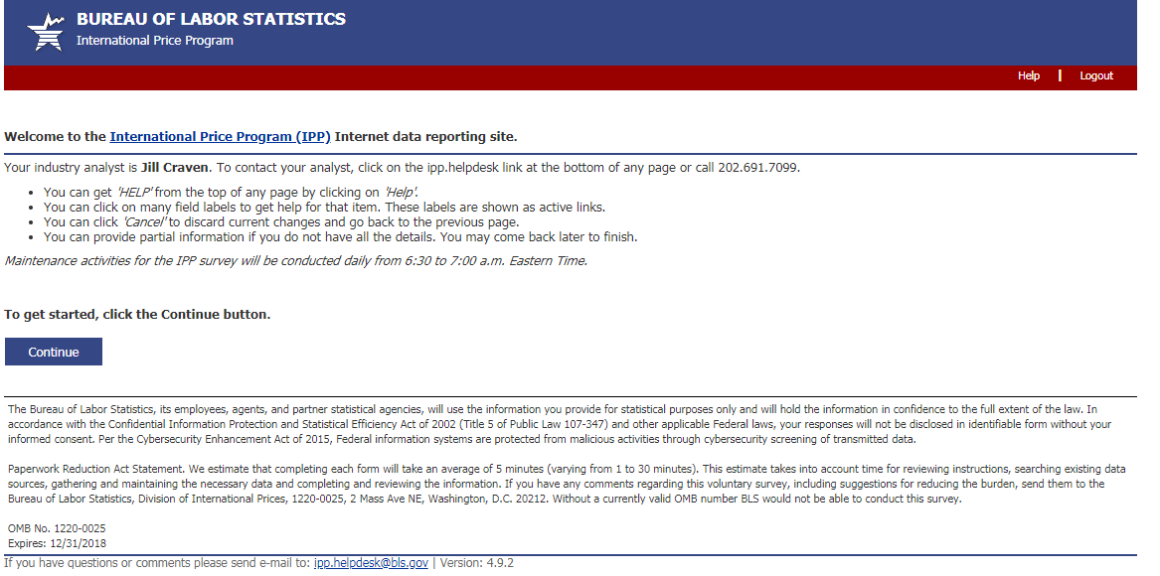

(44 U.S.C. 3572)

**Verify Contact Information screen (Step 1)**

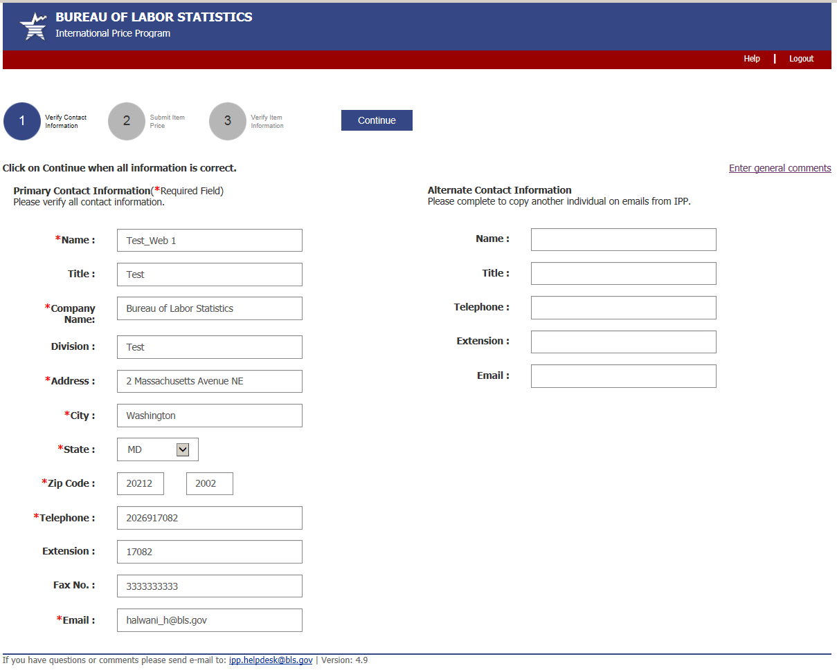

**Submit Price Information Screen (Step 2)**

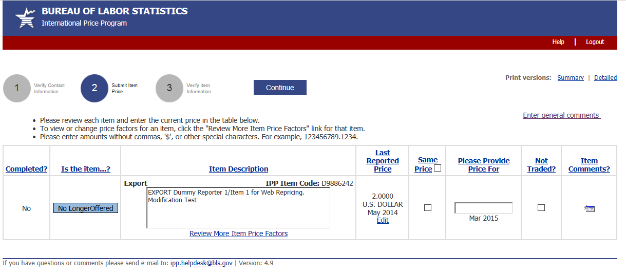

**Verify Price Information Screen (Step 3)**

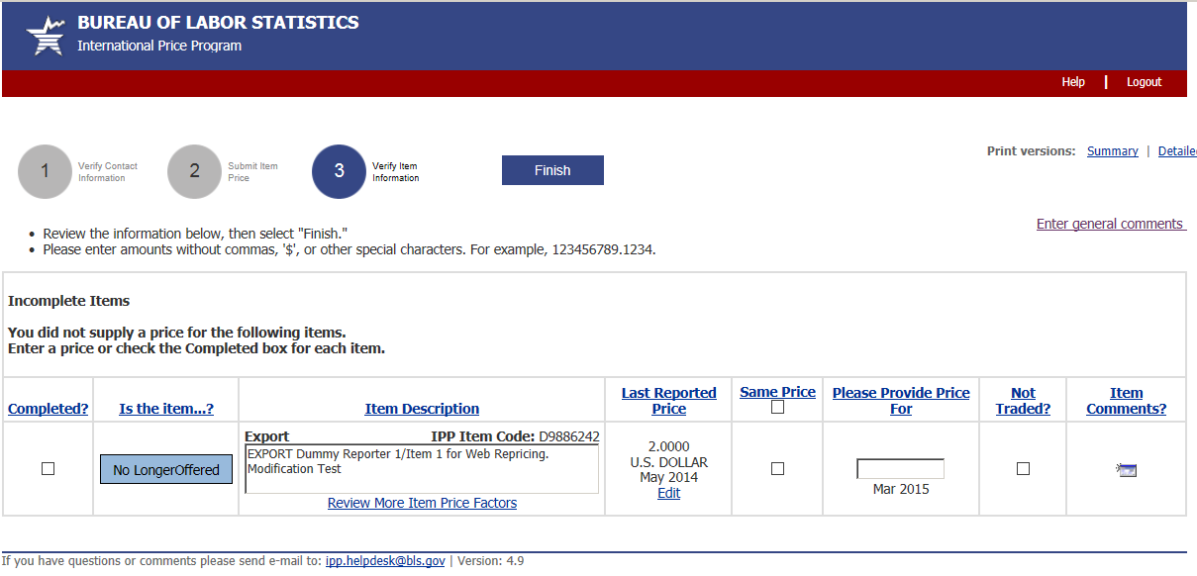

**.**2

**.**2

**More Item Price Factors screen**

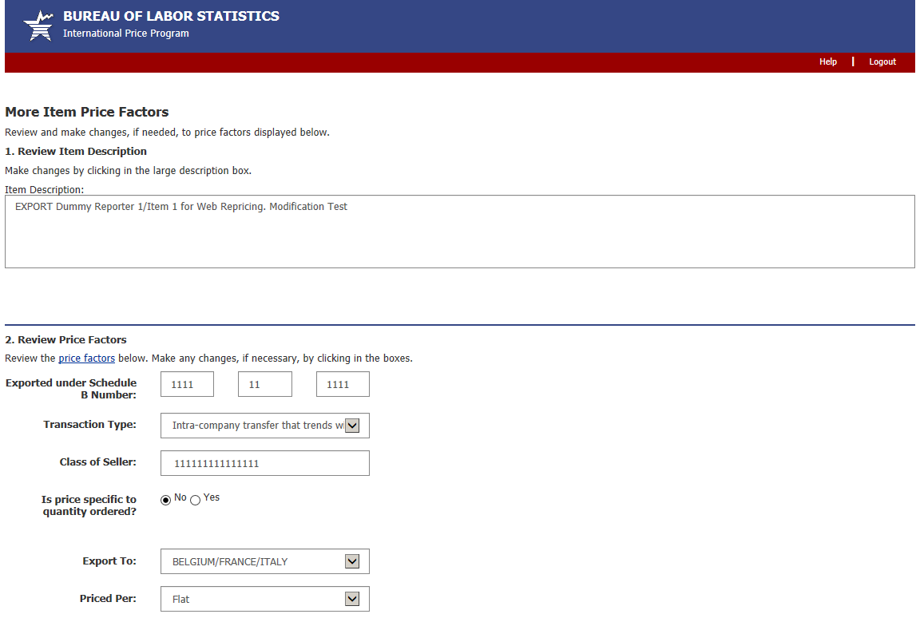

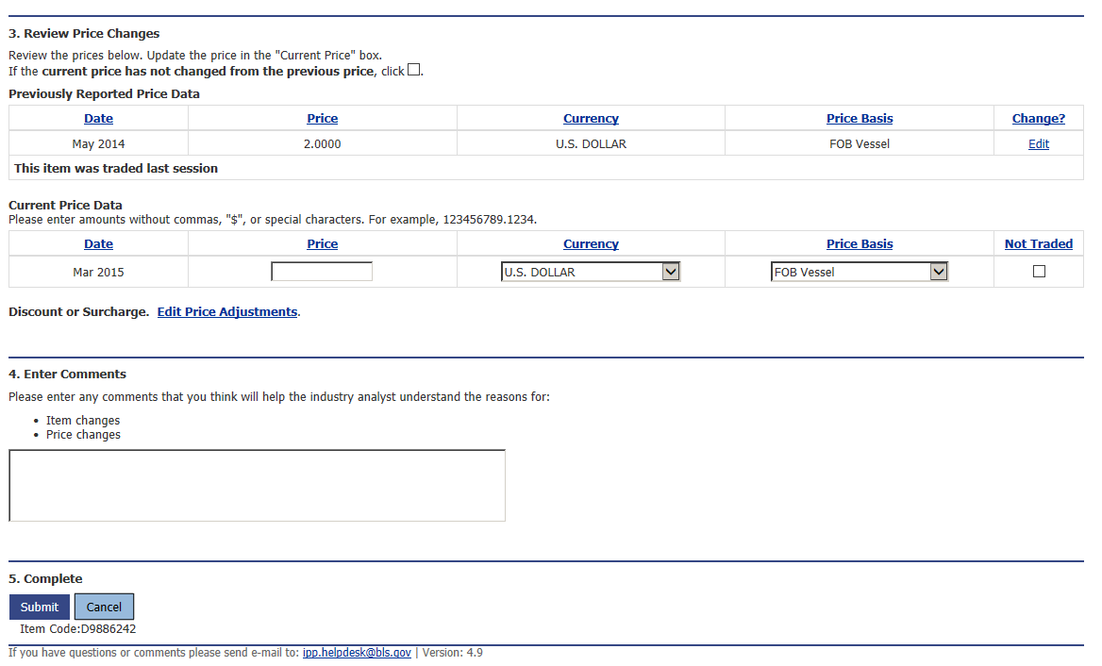

**Edit Price Adjustments screen**

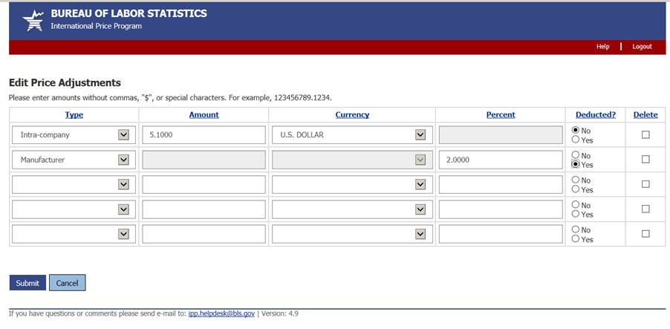

**Review/Verify Large Price change screen**

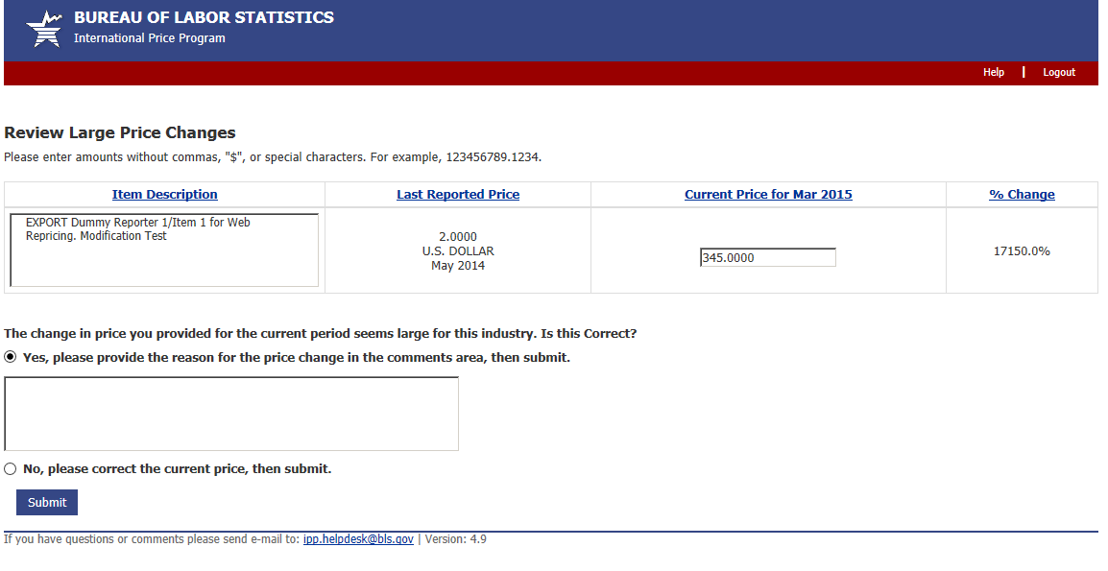

**Review/Verify Cost of Modification screen**

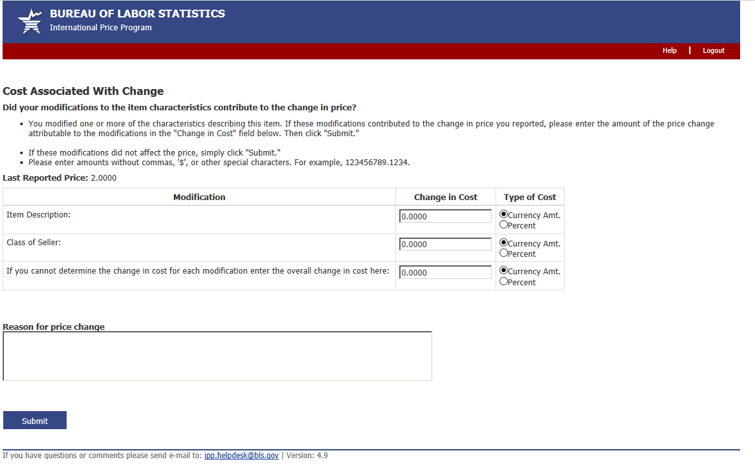

**Update Last Reported Price screen**

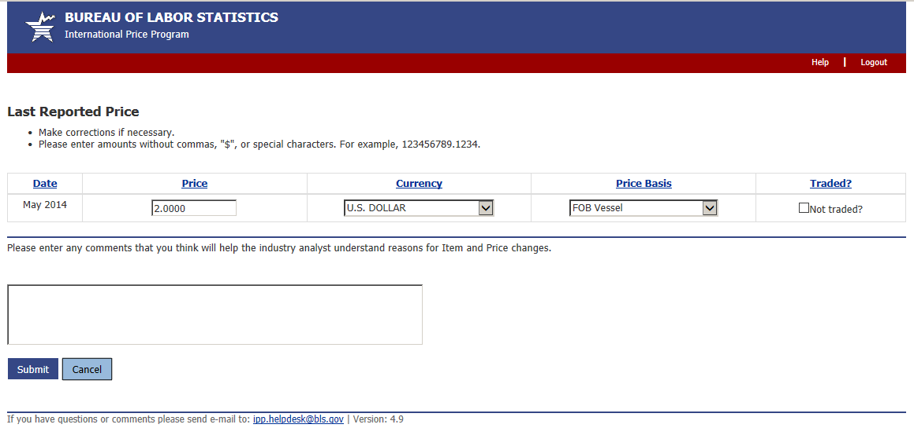

**Discontinue/Replace Item screen**

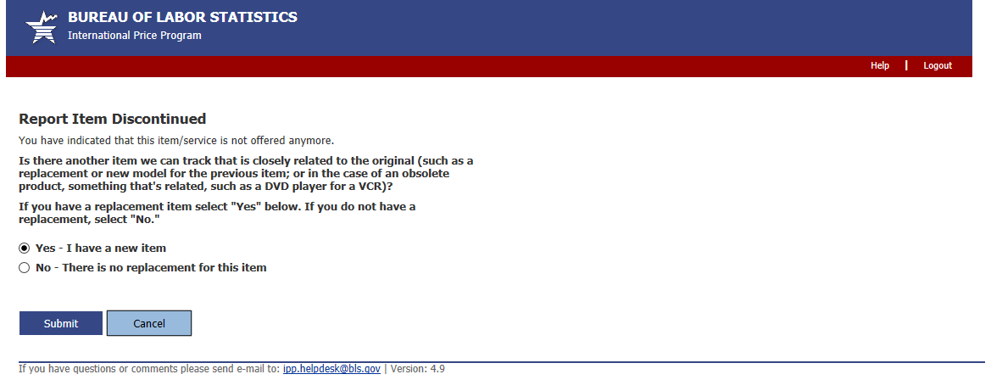

**Replaced Item Screen**

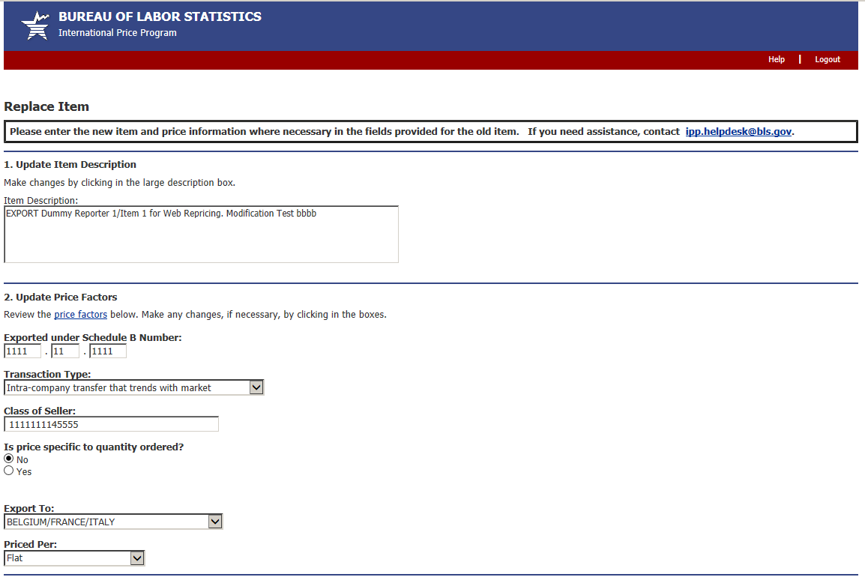

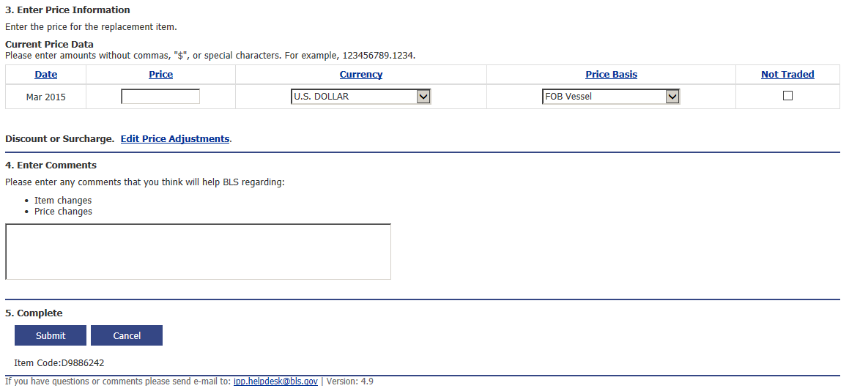

**Undo Replacement screen**

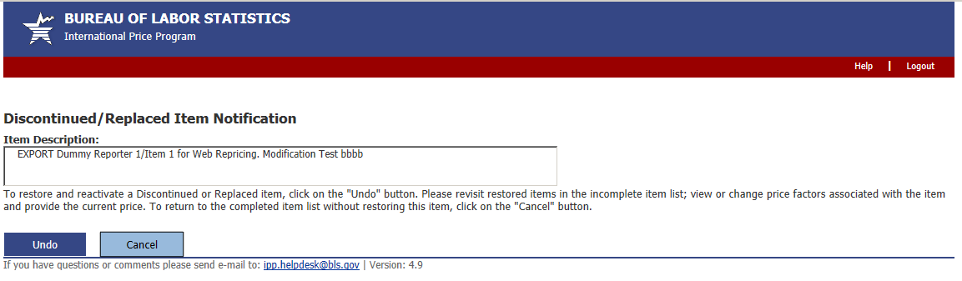

**Thank You screen**

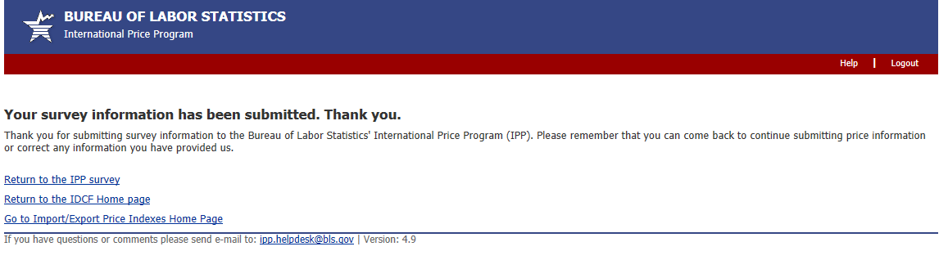

**Privacy and Security Statement**

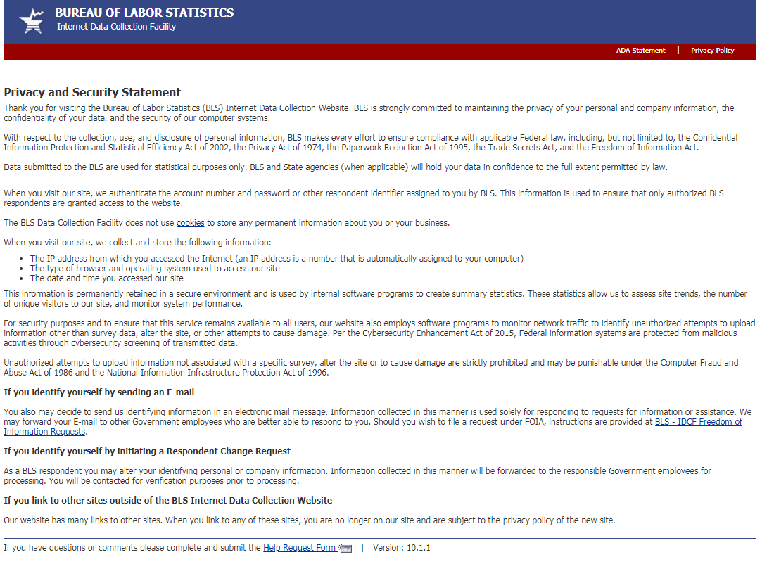

(44 U.S.C. 3572), the Privacy Act of 1974, the Paperwork Reduction Act of 1995, the Trade Secrets Act, and the Freedom Information Act.