Attachment R: Recruitment Flyer for Cognitive Interviewing
Form Approved
OMB No: 0920-xxxx
Exp. Date: xx-xx-xxxx

Public Reporting burden of this collection of information is estimated at 5 minutes per response, including the time for reviewing instructions, searching existing data sources, gathering and maintaining the data needed, and completing and reviewing the collection of information. An agency may not conduct or sponsor, and a person is not required to respond to a collection of information unless it displays a currently valid OMB control number. Send comments regarding this burden estimate or any other aspect of this collection of information, including suggestions for reducing this burden to CDC/ATSDR Reports Clearance Officer, 1600 Clifton Road NW, MS D-74, Atlanta, GA 30333; Attn: PRA (0920-xxxx) or byws@cdc.gov.

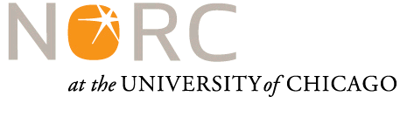
PARTICIPANTS WANTED FOR A RESEARCH STUDY
The National Opinion Research Center is looking for young people aged 13 to 24 to test health and behavior questions that may be used on a survey.
- Are you, or is your child, aged 13-24?

- Are you willing to share your experiences around youth health and how youth are staying healthy?

- Do you currently live in the city of Baltimore and have approximately 60 minutes for an interview?

If you said YES to these questions, we want you to take part in an interview about youth health! If you/your child participates, you will receive $50.
  - The interview will last approximately 60 minutes
  - It can be completed at your home, by having an interviewer come to your house at your convenience or by doing an interview securely over a video call.

If you are interested, please contact NAME to answer a few questions and schedule an interview time at:

STUDY@norc.org
312-XXX-XXXX

