Evaluation of CY2020 Medicare Home Health Services: Data Updates
Analysis of Preliminary 2020 Medicare Claims to Assess the Early Impact of PDGM Implementation and COVID-19 Pandemic on Home Health Agencies

Submitted to:
Partnership for Quality Home Healthcare (PQHH)

Submitted by:


Al Dobson, Ph.D.
Alex Hartzman, M.P.A., M.P.H.
Sandra Agik, Sc.M.
Sung Kim
Joan DaVanzo, Ph.D., M.S.W.

Monday, October 19, 2020

Introduction
This report provides technical and data updates to the prior report that was attached to Partnership for Quality Home Healthcare (PQHH) public comments on the Calendar Year (CY) 2021 Home Health Prospective Payment System (HH PPS) proposed rule. Updates here include: 1) additional months of data (now reporting through June 2020), 2) new adjustment approaches to further elucidate case volume and payment changes compared to projections used in rate setting files, and 3) a correction to our Low-Utilization Payment Adjustment (LUPA) methodology which previously overcounted LUPA claims (however the updated estimate is still nearly 3 times higher than CMS projections).
Dobson DaVanzo & Associates (Dobson | DaVanzo) was commissioned by PQHH to analyze available Medicare home health claims data reflecting the initial implementation of the Patient-Driven Groupings Model (PDGM). Dobson | DaVanzo previously supported PQHH in the review of PDGM as included in the CY2018, CY2019, and CY2020 HH PPS proposed and final rules, as well as accompanying technical reports. To inform our analyses and conclusions, we draw on this prior work along with other responses to the prior comment periods, the Abt Technical Expert Panel report, as well as early 2020 claims data, published CY2020 PDGM case-mix weights, and CY2020 rate-setting and impact files.
Effective January 1, 2020, the PDGM overhauled the HH PPS episode and case-mix group definitions, payment weights and base rate. PDGM is a revision of the Home Health Resource Group (HHRG) case-mix group definitions initially proposed in the CY2018 HH PPS administrative rulemaking cycle that was refined and finalized in the CY2019 and CY2020 HH PPS rulemaking cycles. The CY2021 HH PPS rule proposes limited changes to PDGM. Complicating the preliminary evaluation of PDGM implementation is the ongoing novel coronavirus (COVID-19) public health emergency (PHE).
Comparison of preliminarily available 2020 Medicare claims to projections used in rate setting indicates that home health case volume, total payments, and average payments have declined in 2020, and that LUPA case rates have increased. While it is difficult to parse what effects are due to the PDGM implementation itself and what are due to the ongoing COVID-19 PHE, the outcome is that it appears so far that the CY2020 HH PPS is not budget neutral to prior years. Using available data from January-June 2020 we estimate the system payment rate to be approximately 5% below budget neutral payment levels; we discuss budget neutrality in terms of payment rate which is not affected by the PHE-related decline in case volume. Agency adjustments made in the remainder of the year appear unlikely to make up for the payment rate shortfall, in part due to prospective reductions to the base payment rate for assumed provider behavioral changes enacted by CMS.
When implementing PDGM in the CY2020 Final Rule (FR), CMS prospectively reduced the HH PPS base rate from the budget neutral calculated level by 4.36%. This prospective base rate reduction is inherently a significant contributor to the observed payment shortfall – even without this reduction, payments would still be below budget neutral levels. The level of rate reduction was justified by CMS though analytic assumptions on how providers might change their behavior once PDGM was implemented. In the CY2020 FR, CMS described three underlying assumptions to determine the behavioral adjustment:
- For one-third of LUPAs that are one to two visits away from the LUPA threshold, HHAs will provide one to two extra visits to receive a full 30-day payment.
- HHAs will change documentation and coding practices and put the highest paying diagnosis code as the principal diagnosis code (payment optimized clinical coding). This allows a 30-day period of care to be placed into a higher-paying clinical group.

- By taking into account additional ICD-10-CM diagnosis codes listed on the HHA claim (that exceed the six allowed on the OASIS), more 30-day periods of care will receive a comorbidity adjustment than periods otherwise would have received if CMS had only used the OASIS diagnosis codes for payment.
CMS based its projections and assumptions in the CY2020 FR using 2018 claims data (paid through July 31, 2019) to inform its calculations. Now ten months into the implementation of the new payment system, there are preliminary data to evaluate whether these assumptions have held true. However, it is important to note that home health providers have also been grappling with the ongoing COVID-19 PHE as well as widespread state-level public policy actions beginning in March of 2020.
Using preliminary 2020 Medicare claims, we find that the behavioral assumptions for PDGM implementation have not held true. Furthermore, these erroneous assumptions have implications for home health market stability and subsequently beneficiary access to home health services. We find evidence that neither the LUPA assumption nor the payment optimization of clinical coding assumption have occurred through June 2020. Analyses of preliminarily available data suggest that the COVID-19 PHE may have led to an apparent increase in case-mix severity for the high comorbidity and high functional need groups; utilization decreased overall and LUPA rates increased, but less so among cases with high comorbidity and functional need scores, suggesting patients with the most severe needs were more likely than others to receive full episodes of care.
We commend CMS for making extensive case data available and showing transparency to enable robust and productive commentary by the public. In the CY2020 FR CMS OASIS-LDS PDGM rate-setting and impact files, CMS provided payment estimates which included case-level estimated behavioral responses, as well as data appropriate for reproducing PDGM payments without behavioral responses.

Summary Findings
We find that the CY2020 HH PPS so far appears to have been implemented at a below budget neutral level. Further, anticipated behavioral changes, case shortfalls and volume reductions deviate from the trends CMS predicted in its initial projections.
- Budget Neutrality: PDGM does not appear to be budget neutral compared to prior years measured either by average or total aggregate payments.
  - Over the first six months of PDGM implementation, observed average case payments were 4.9-5.2% lower than projected (average case payment of $1,718-1,723 January-June 2020 (depending on January adjustment approach) compared to projected $1,812 from January-June of the FY2020 FR file).
  - After accounting for case-volume reductions, total aggregate payments are about 12.5-18.3% lower than projected ($7.1-7.6B observed (depending on adjustment approach) compared to $8.6B expected for the period).
  - We are confident that findings are robust with over 4.1M home health episodes during the period. We anticipate further changes as providers continue to adapt to PDGM and navigate the unfolding COVID-19 PHE, however, preliminary data provides evidence that corrective action may be warranted to appropriately pay home health providers in CY2021.

- Case Volume Shortfall: We find a 8.0-13.9% reduction in home health episode volume from PDGM and the COVID-19 PHE January-June 2020 compared to the rate-setting file (depending on adjustment method):
  - PDGM case utilization decreased due to the shift from 60-day episodes to 30-day cases and the timing of visits within an episode of care.
    - Projections used in rate-setting also had inherently reduced volume due to data cleaning procedures which removed paid cases; the comparison to historical projections does not fully capture the complete decline in case volume and potentially leads to an underestimate of the shortfall.
    - We also find that each 60 day home health period translates to 1.25 30-day PDGM periods on average, lower than the rate anticipated by CMS (1.76).
  - Additionally, the decline in home health volumes can be largely attributed to the COVID-19 PHE as states enacted restrictions to control the spread of the virus. These policy actions enacted mandated lockdowns that halted elective procedures, delayed other procedures, and did not designate therapists as essential workers during the initial onset of the pandemic. Patients were and remain wary of allowing healthcare workers into their homes to some extent during the pandemic.
    - Some portion of home health visits was shifted to telehealth during this time however, this shift is not captured in the claims data, per CMS pandemic flexibilities guidance. HHAs can report costs of telehealth on the HHA cost report, but not completely. Lack of data on telehealth services has implications for future HH PPS rate-setting and rebasing.

- Behavioral Assumptions: In HH PPS rulemaking, CMS assumed that agencies would automatically and instantaneously change their coding and visit allocation behavior to maximize reimbursement under the novel payment system. Our results show that home health agencies thus far have not followed this behavioral assumption described by CMS in the CY2020 HH PPS final rule to justify the prospective base rate reduction of 4.36%.
  - LUPA rates in 2020 so far are much higher than anticipated, which has contributed to a low measured per-case payment rate as well as low total aggregate case payments. In the first four months of the year when home health agencies were adjusting to PDGM, the national LUPA rate was 14.4% with an all-time high of 18.2% in March. While the pandemic dramatically impacted home health activities, we observed a spike in LUPA rates even prior to the onset of pandemic responses in March. This suggests that agencies were struggling with the new PDGM LUPA threshold requirements before the pandemic.
  - Case-mix groups reflect historical trends of primary diagnoses rather than payment-optimized groupings. While CMS assumed that some portion of cases would have their claims submitted such that the highest paying clinical group diagnostic code reported anywhere on the claim would be chosen for the primary diagnosis code, our results show that this has, by in large, not happened. Clinical case-mix groups observed are much more like historical trends from the rate-setting file without the behavioral adjustment.
  - Comorbidity and functional group scores are higher than anticipated which may be some part behavioral adjustment but also a relative increase in case-mix severity from historical trend. CMS assumed that some cases would have additional comorbidities reported that were also reported elsewhere in that beneficiary’s home health claims or assessment data. While preliminary 2020 claims data show that providers have an increased rate of high comorbidity and functional need cases, total volume of high comorbidity and functional need patients remained relatively consistent to projections from historical trends. Providers are increasingly supplying care to patients of higher complexity, despite or perhaps because of the overall reduction in volume accompanying the COVID-19 PHE.

- Case-Mix Severity: Overall aggregate case-mix weights during the period were 1.05 and did not meet the level anticipated in behavioral adjusted projections of 1.08.
  - Case-mix severity in general was higher than historical trends for PDGM (1.01). We further explored issues around case volume decline, LUPA rates, and PDGM case mix group categories and case-mix weights. This provided additional evidence suggesting that increases in case-mix severity are more due more to volume declines (where higher need cases are more likely to receive visits) rather than coding changes.

- Policy Implications: Findings have implications for rate-setting in CY2021.
  - The lack of observed provider behavioral responses so far suggests CMS behavioral assumptions may not come to pass; some part of the occurrence of increased case-mix severity may be a response to the COVID-19 PHE. CMS is explicitly authorized under the Bipartisan Budget Act of 2018 to adjust the CY2021 HH PPS base rate temporarily or permanently to achieve budget neutrality.
  - The COVID-19 PHE response activities among states, CMS, and providers all serve to make data from this time less reliable and representative than the typical data used for rate-setting, rebasing, and payment reform.
    - This has implications for everything from future rebasing of the HH PPS to the IMPACT Act timeline.

Detailed Findings
The Bipartisan Budget Act of 2018 mandated CMS to develop a new payment model for the Medicare home health program with a number of requirements, namely that: 1) HH PPS cases are shortened from 60 days to 30 days, 2) cases are no longer paid based on volume of therapy services and 3) changes are implemented in a budget neutral manner. We examined the actual changes in coding under PDGM compared to CMS projections using data from early 2020 claims files and the CY 2020 CMS OASIS-LDS PDGM rate-setting file.
- Preliminary 2020 claims were available to Dobson | DaVanzo under CMS Research Identifiable File (RIF) Data Use Agreement (DUA) 54757. Data included in this report go through June 2020, the most recent available month with sufficient claims run out. The previous report included data through April 2020.
- Historical projections of PDGM using 2018 data and including both a regrouping of HH PPS cases to PDGM as well as the behavioral assumptions are available in the CY2020 OASIS-LDS file, Data Use Agreement 53367. This dataset was issued as a companion to the CY2020 Final Rule.

Budget Neutrality
We find that PDGM does not appear to be budget neutral at its currently implemented payment levels, indicating higher base payments may be required to achieve budget neutrality. Over the first six months of implementation, average case payments were reduced by 5.2%. In Exhibit 1, we show the rate-setting file outputs with CMS behavioral adjustments (Full BA) and without behavioral adjustments (No BA) compared to observed rates from preliminary 2020 RIF claims. Average case payments were partially inflated in January due to the transition to PDGM (more higher paying “early admission timing” cases because “late admission timing” cases could not occur, increasing average payment) which declined in subsequent months. Per-case payment rates declined subsequently and have yet to recover to budget neutral levels.
Exhibit 1: Actual CY2020 Claims Average Case Payments vs. Projected Case Payments with and without Behavioral Adjustments
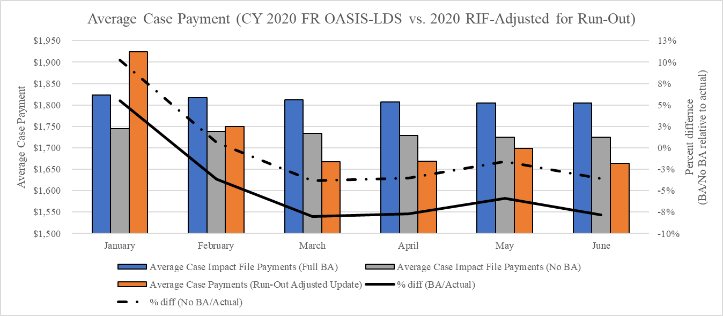
Source: Dobson | DaVanzo Analysis of HH Claims in DUAs LDS 53367 and RIF 54757
Total HH PPS payments have declined for this period as well. For the January-June period, we found that overall case payments declined by over 18%. Low total case payments in January are partially due to transition effects (we measure claims by admission date), and February may be similarly affected.
In Exhibit 2 we make a additional adjustment to account for the fact that the rate setting file projections assumed a continuous roll-over of PDGM from a prior year. In actuality, the system transitioned from the 153-group HHRG system, and 60-day episodes in progress did not automatically convert to PDGM 30-day cases. To account for this non-rollover we applied an adjustment to account for cases that did not automatically covert to the 30-day PDGM system. We did so by multiplying December 60-day case counts by a factor of 1.76 to convert to 30-day episodes, with 43% (0.76/1.76) of converted cases and payments to be added to observed 2020 cases. This lowers the measured average January case payment to $1,880 (measured at $1,924 in Exhibit 1), but also adds more case weight to January, leading to an overall average case payment of $1,723 or 4.9% below budget neutral levels.
Exhibit 2: Actual CY2020 Claims Average Case Payments vs. Projected Case Payments with and without Behavioral Adjustments, Adjusted for Non-Rollover of 153-Group System
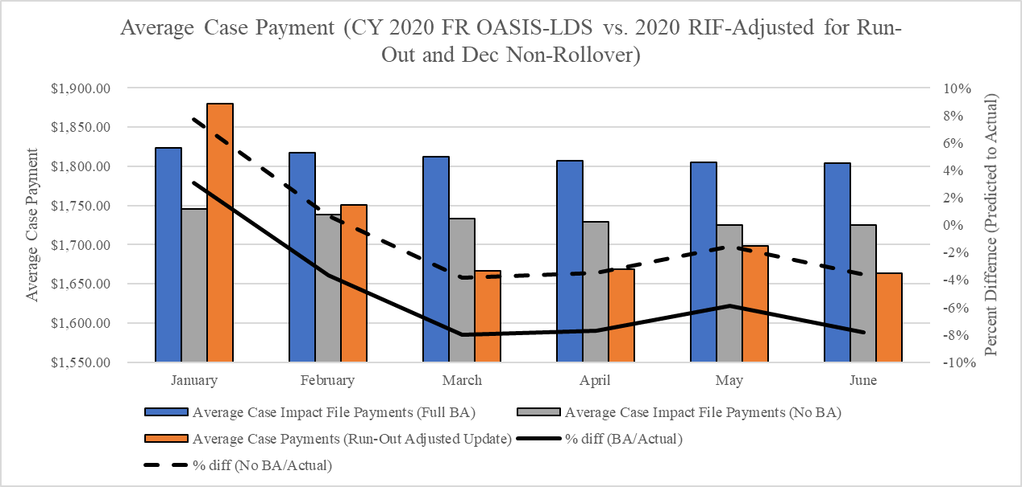
Source: Dobson | DaVanzo Analysis of HH Claims in DUAs LDS 53367 and RIF 54757
However, we do find substantial overall home health revenue decreases particularly in March through June, most likely the primary contributors being reduced volume and increased LUPAs as a result of the COVID-19 PHE (Exhibit 3 and Exhibit 4).

Exhibit 3: Actual Total CY2020 Medicare HH Case Payments Compared to Projected Total Payments (with and without Behavioral Assumptions)
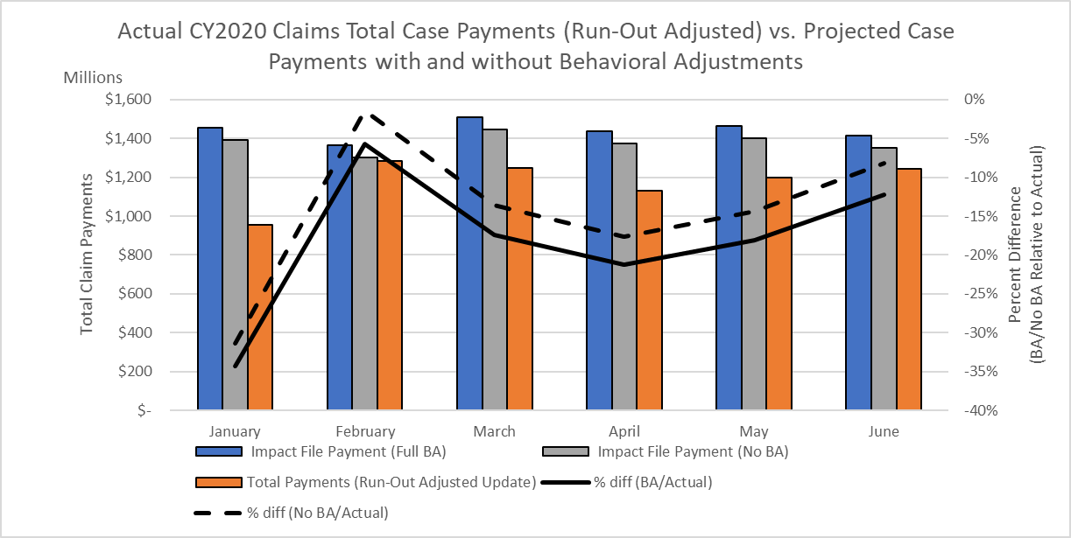
Source: Dobson | DaVanzo Analysis of HH Claims in DUAs LDS 53367 and RIF 54757

Once again, we demonstrate the addition of an adjustment for December-to-January roll-over. To simulate roll-over from the 153-group system by converting 60-day periods to 30-day periods, we spread payments for 60-day cases that began in December across December and January.
Exhibit 4: Actual Total CY2020 Medicare HH Case Payments Compared to Projected Total Payments (with and without Behavioral Assumptions), Adjusted for Non-Rollover of 153-Group System
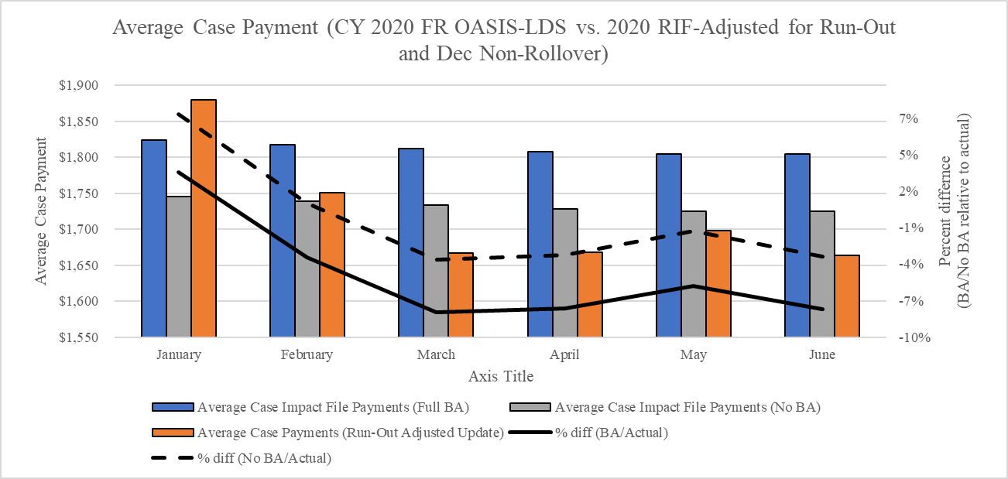
Source: Dobson | DaVanzo Analysis of HH Claims in DUAs LDS 53367 and RIF 54757

Overall, we estimate that January-June 2020, the HH PPS payment system output is 12.5-18.3% below anticipated payment levels, depending on the adjustment approach taken for January cases.

Case Volume Shortfall
We observe significant changes in home health volumes in the first third of 2020. This can in part be explained by the shift from 60-day to 30-day episodes of care, but is largely due to the onset of the COVID-19 PHE.
Case volume has declined in this period as shown in Exhibit 5. January actual case counts are lower than anticipated largely due to the transition to PDGM (ongoing 153 group system 60-day cases complete rather than switch to 30-day cases); this is adjusted for in Exhibit 6. Case counts in February (when the transition to PDGM is mostly complete) were close to projected levels (2% lower than expected). Case volume is reduced in March through June with the nadir in April, likely due to the COVID-19 PHE and widespread state-level countermeasures being enacted at the beginning of March. January-June volume ranges from a reduction of 13.9% (Exhibit 5) to 8.0% (Exhibit 6), depending on the adjustment approach for January.
Note that these estimates of the shortfall on case volume and total payments may be low because the rate-setting file included substantial (and not fully specified) cleaning procedures that exclude more cases than would be otherwise be paid.
Exhibit 5: Actual CY2020 Case Count vs. Projected Case Count (Behavioral Adjustments Not Applicable)
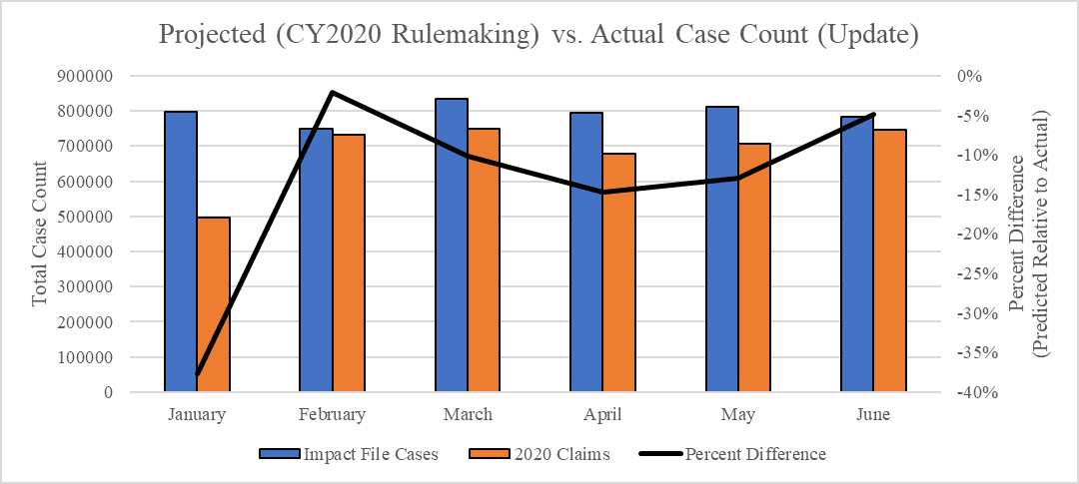
Source: Dobson | DaVanzo Analysis of HH Claims in DUAs LDS 53367 and RIF 54757
Exhibit 6 Actual CY2020 Case Count vs. Projected Case Count (Behavioral Adjustments Not Applicable) , Adjusted for Non-Rollover of 153-Group System
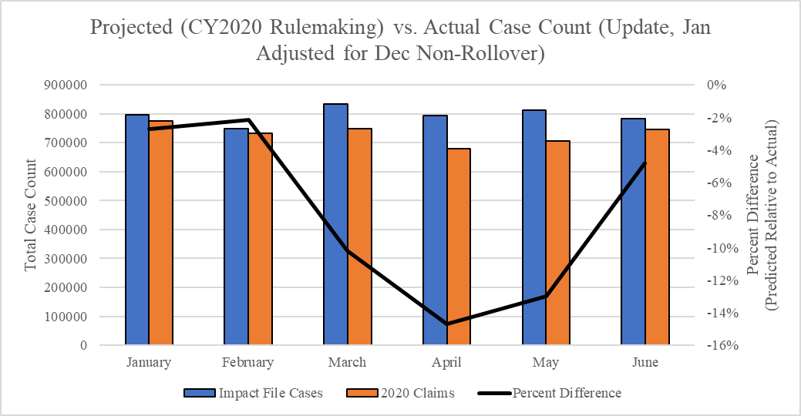
Source: Dobson | DaVanzo Analysis of HH Claims in DUAs LDS 53367 and RIF 54757

We examined COVID-19-related diagnostic codes for home health users in 2020. This includes coding for presumed or confirmed cases, possible exposure, negative screenings, historically used (and retired codes), and related severe symptoms (pneumonia or bronchitis due to viral or other cause). We examined inpatient, outpatient, physician office and home health claims during the home health episode and in the 30 days prior to home health admission to measure the direct service risk of home health providers in Exhibit 7. As anticipated, we find the COVID-19 case rate among home health users – as well as reports of possible exposure and negative screening – are increasing over the period. COVID-19 patients represent a small portion of home health case load (~2.45% in June).

Exhibit 7: COVID-19 Case Rates, Related Symptoms, and Related Codes, Among CY2020 Home Health Users
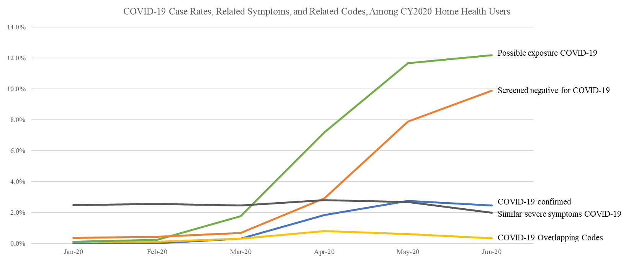
Source: Dobson | DaVanzo Analysis of HH, IP, OP, and Carrier Claims, RIF 54757

Behavioral Assumptions
The CY2020 HH PPS FR presented the 30-day payment rate in a budget-neutral manner for PDGM cases, then reduced that budget neutral base rate by -4.36% based on assumptions that providers would systemically change their visit volume and coding practices to maximize payment in the new model.
CMS cited three underlying assumptions to justify the payment reduction in the final rule:
- For one-third of LUPAs that are one to two visits away from the LUPA threshold, HHAs will provide one to two extra visits to receive a full 30-day payment.
- HHAs will change documentation and coding practices and put the highest paying diagnosis code as the principal diagnosis code. This allows a 30-day period of care to be placed into a higher-paying clinical group.
- By taking into account additional ICD-10-CM diagnosis codes listed on the HH claim (that exceed the six allowed on the OASIS), more 30-day periods of care will receive a comorbidity adjustment than periods otherwise would have received if CMS had only used the OASIS diagnosis codes for payment.
Combined, the agency indicated in the CY2020 HH PPS proposed rule that these three assumptions (which are interactive) would lead to 8.01% overrun; in the final rule, CMS reduced this to 4.36%. As described above, we find that the HH PPS is underpaying relative to budget neutral levels; below we address each behavioral assumption in greater detail. Ultimately, we find the behavioral assumptions have largely not come to pass:
- Observed LUPA rates greatly exceed predicted rates.
- Payment optimization of primary diagnostic coding has largely not occurred (clinical case-mix groups represent historical rather than optimized groupings).
- High comorbidity and functional need groups are bigger than expected, but this is tempered by increased relative case-mix severity with reduced volume.

LUPA Rates
During this period, LUPA rates were much higher than historically or in the rate-setting file (with or without behavioral adjustment). LUPAs are cases that do not meet the full payment visit threshold and are paid on a per-visit basis; the large portion of LUPA cases serves to reduce average case payments. We find a 14.4% LUPA rate in January-June 2020 compared to the predicted 5.4% (with behavioral assumptions) or 7.5% (historical trend without behavioral assumptions). LUPA rates were very high and increasing in the PDGM case mix groups in January and February, prior to widespread state responses to the COVID-19 PHE, as shown in Exhibit 8. This suggests that providers were struggling with the new PDGM LUPA rules.
LUPA rates began trending back down after March; however, LUPA rates would have to be consistently below 5% for the remainder of the year to come back to the CMS behavioral assumption of an aggregate 5.3% LUPA rate.
Exhibit 8: Actual CY2020 LUPA Rate vs. Projected LUPA Rate
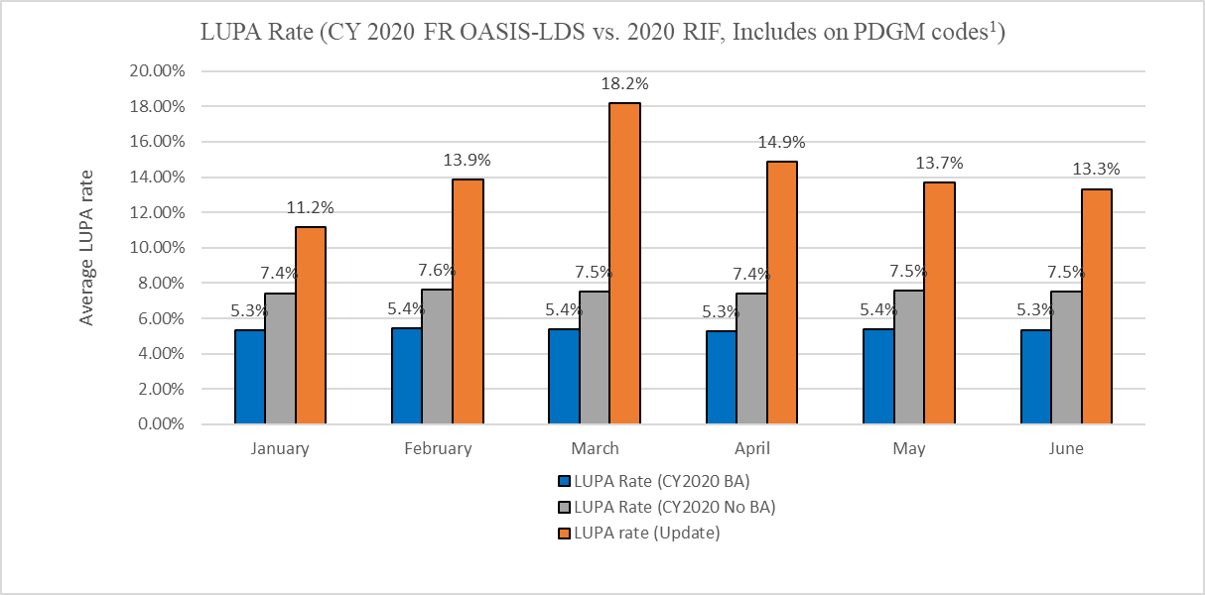
Source: Dobson | DaVanzo Analysis of HH Claims in DUAs LDS 53367 and RIF 54757

Clinical Group Coding
We find that case-mix groups are more similar to historical trends of primary diagnoses rather than payment-optimized groupings as projected by CMS in the behavioral assumptions, as shown in Exhibit 9. The Agency assumed home health agencies would change their documentation and coding practices to assign the highest-paying diagnosis code as the principal code for the 30-day period of care, which has largely not occurred. Certain groups stand out for their departure in the behavioral assumption group from historical trend – especially clinical groups MMTA-Endocrine and Neuro groups – where actual 2020 case-mix results hewed close to historical levels. This behavioral assumption would require agencies to substantially disregard international agreed coding schemas, so it is unsurprising shifts did not occur to the extent predicted in the behavioral assumption.
Exhibit 9: Observed Clinical Groups January-June 2020 Compared to Projected Clinical Groups (with and without Behavioral Adjustments)
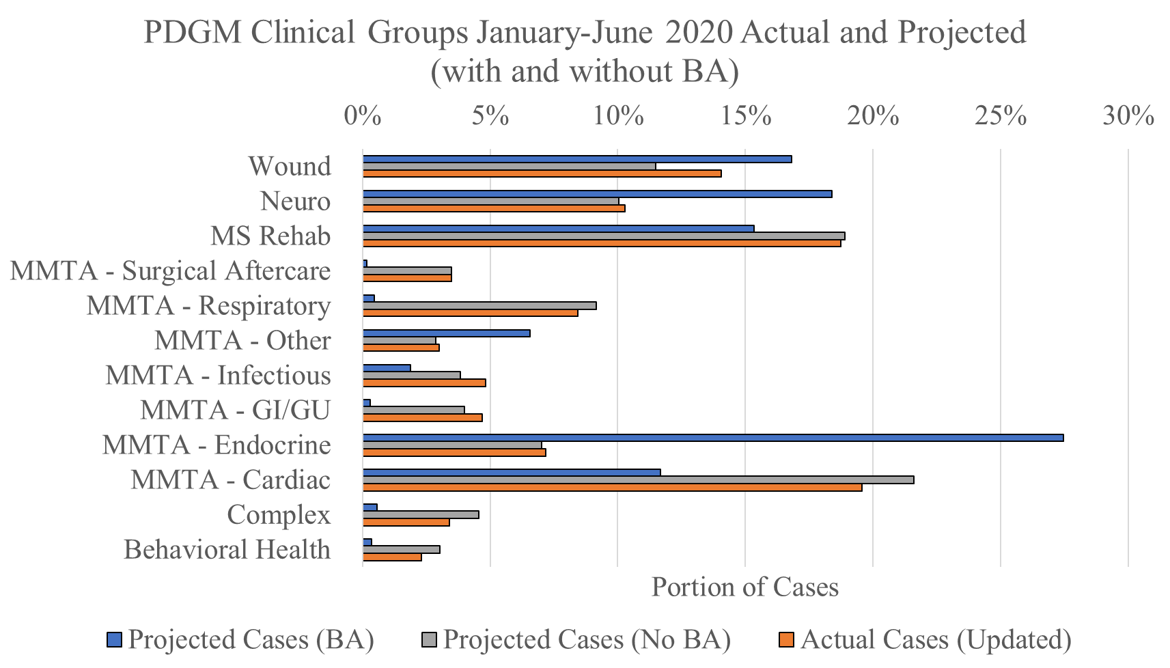
Source: Dobson | DaVanzo Analysis of HH Claims in DUAs LDS 53367 and RIF 54757

Impact on comorbidity coding
So far in 2020, agencies are reporting higher comorbidity and functional group scores, even much higher than scores projected from the rate-setting files with behavioral adjustment as seen in Exhibit 10. The increases in scores could be partially explained by the change in coding behavior as anticipated by CMS but also by the relative increase in case-mix severity due the ongoing coronavirus pandemic. However, it is difficult to determine by how much each factor contributed to the observed comorbidity coding changes.

Exhibit 10: PDGM Case-Mix Categories January-June 2020, Actual and Projected (with and without BA)
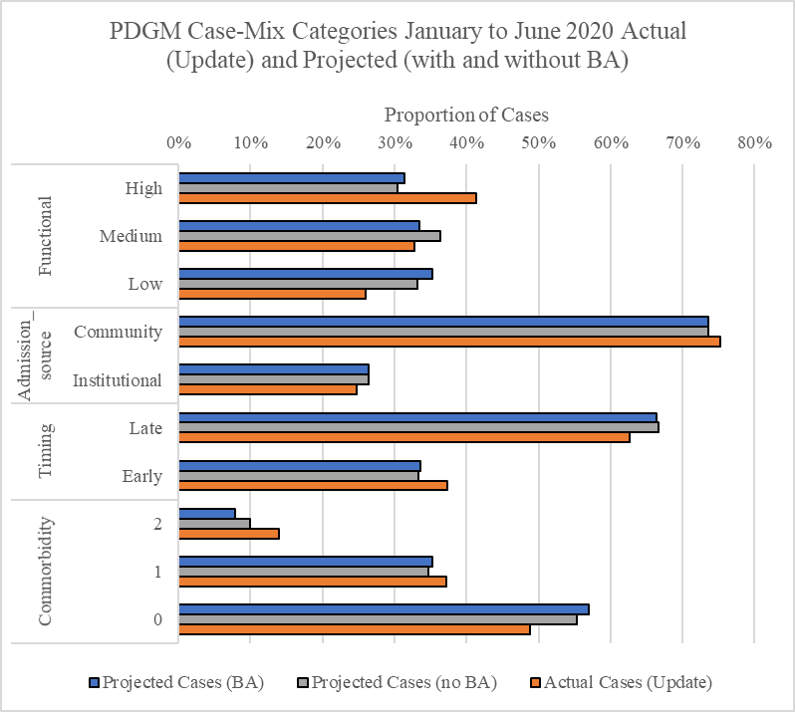
Source: Dobson | DaVanzo Analysis of HH Claims in DUAs LDS 53367 and RIF 54757
While the above data in Exhibit 10 show that providers coded for high comorbidity and functional status more frequently, total volume of high comorbidity and functional need patients remained relatively consistent as shown in Exhibit 11. This suggests that observed shifts are more likely due to the COVID-19 PHE – as overall case volume drops, cases that still occur are likely to serve higher need patients.
Exhibit 11: High Functional Group and Comorbidity Tier Total Volumes vs. Projections with and without Behavioral Adjustment
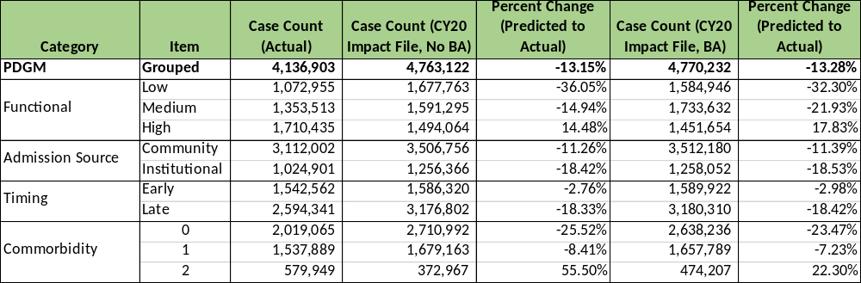
Source: Dobson | DaVanzo Analysis of HH Claims in DUAs LDS 53367 and RIF 54757
These issues tie into overall case-mix severity observations, below.

Case-Mix Severity
A key issue in both the transition to PDGM and the ongoing COVID-19 PHE is the overall severity or patient service need of home health users. We apply the aggregate case-mix weight as a numerical signifier of case-mix severity (or patient service need) as it denotes the expected relative case resource use. As the pandemic has led to major volume declines, the apparent case-mix severity has increased given the insensity of the remaining cases. From our observations, it appears that the volume decline and LUPA rate increases affect lower severity cases. In other words, patients who needed greater service use were more likely to get home health care and have a fully paid episode than otherwise.
For January-June 2020, we compare the aggregate case-mix weights across cases:
- Projected without Behavioral Assumption: 1.01
- Projected with Behavioral Assumption: 1.08
- Observed claims: 1.05
However, as shown above in Exhibit 11, the relative increase in case-mix weights may be driven by a reduction in low-severity cases more than changes in coding. Indeed, clinical groups coding remained close to historical case-mix while overall severity increased.
This results in apparent shifts in aggregate case-mix weight across payment categories in Exhibit 12 and Exhibit 13. Case-mix severity increases appear to be largely due to the distribution of cases across the functional groups in Exhibit 13. While all other case-mix variables show some amount of shift from historical expected case-mix weights, the functional groups are very close to the historical weights. This indicates that holding the functional status constant, case-mix severity did not change substantially – in other words, increases in apparent severity appear largely driven by the distribution of cases across functional groups.
Exhibit 12: Observed Average Clinical Group Case-Mix Weight January-June 2020 Compared to Projected Clinical Groups (with and without Behavioral Adjustments)
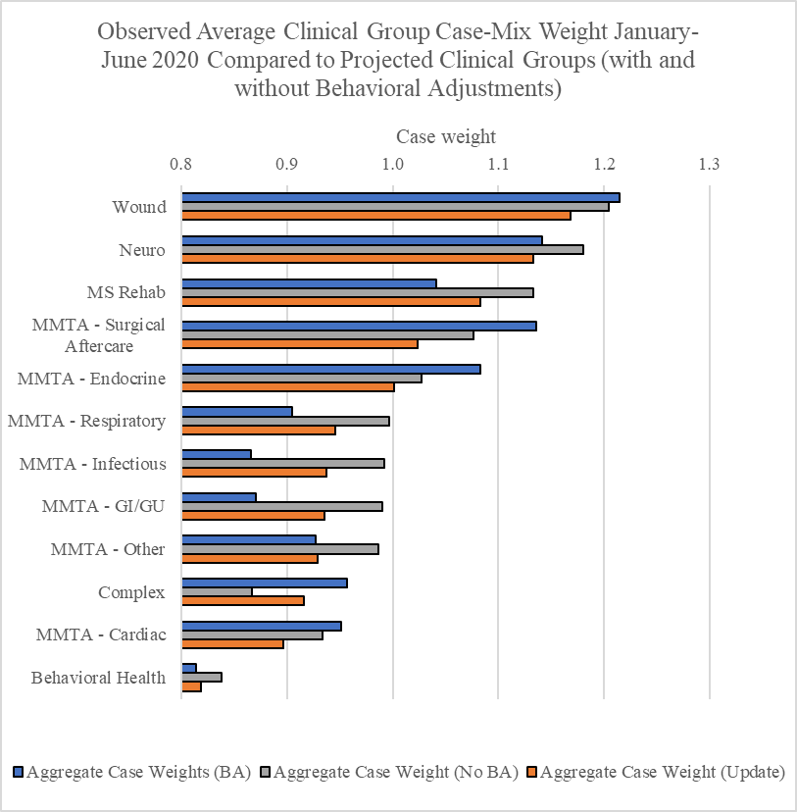
Source: Dobson | DaVanzo Analysis of HH Claims in DUAs LDS 53367 and RIF 54757
Exhibit 13: PDGM Case-Mix Categories Average Case Weights, January-June 2020, Actual and Projected (with and without BA)
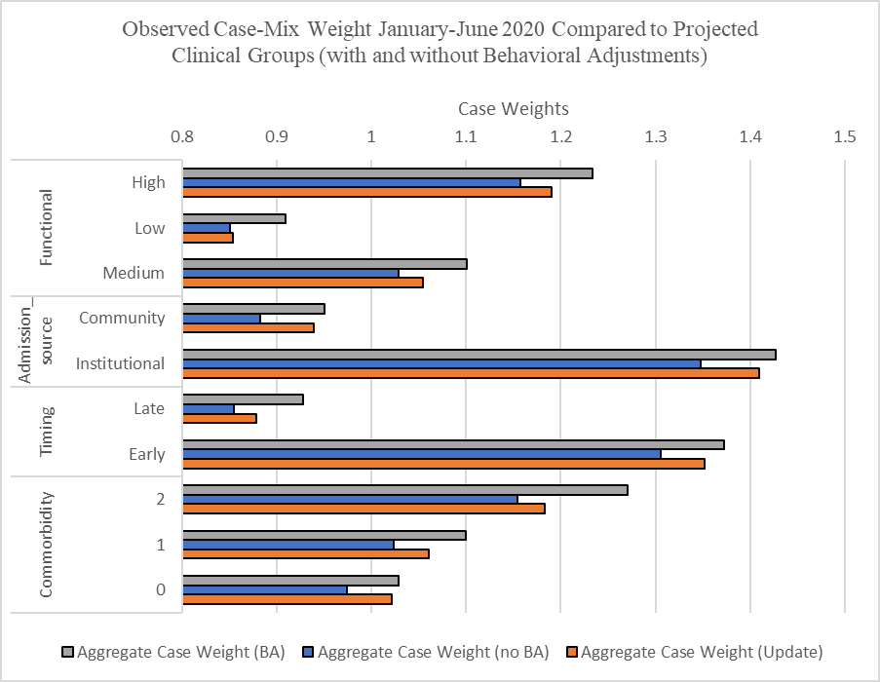
Source: Dobson | DaVanzo Analysis of HH Claims in DUAs LDS 53367 and RIF 54757

Conclusion and Policy Implications
CY2020 PDGM implementation has disrupted home health operations which were then coincidentally impacted by the COVID-19 PHE. Regardless of the root cause, two of the three anticipated behavioral changes that CMS used to justify prospective payment rate reductions have not occurred as of June – overall payments and case volume are down with very high LUPA rates. This affects case-mix severity in complex ways; the PHE may be the predominant cause of the observed increase in case-mix severity rather than provider coding adjustments.
In the near-term, CMS may consider taking corrective action to increase the base rate so the HH PPS will be more likely to achieve budget neutrality in CY2021, as authorized by the Bipartisan Budget Act of 2018. We do not suggest that CMS take supportive action for home health agencies via the HH PPS as a bulwark for beneficiary access amidst the ongoing PHE; other policy mechanisms of action are being applied to that purpose and these actions address the volume shortfall. Rather, we discuss budget neutrality in terms of average payment which is not affected by this volume shortfall – regardless of other mechanisms used to support agencies through COVID-19, the 2020 base payment rate is not budget neutral which affects payment adequacy in the near- and long-term. Looking ahead, PDGM implementation and regulatory changes enacted (temporarily or permanently) to support beneficiary access and health during the COVID-19 PHE will leave a lasting imprint on the data used to rebase, set payment weights, and eventually transition to new payment systems.
The allowance of telehealth visits for home health services after the LUPA threshold is reached is potentially helpful in assuring continuous beneficiary access during the COVID-19 PHE, particularly for some monitoring and teaching services (among others) which may reasonably shift from in-person care to telehealth. However, there is no requirement to capture these services in the claims and telehealth costs are not well-reported in Medicare Cost Reports. As such, the service shift toward telehealth must be accounted for outside of the traditional rate setting and rebasing models at the risk of decreasing the payment accuracy and adequacy of the HH PPS.
Atypical volume and case-mix severity is occurring across all healthcare providers during the COVID-19 pandemic. Other COVID-19 PHE responses also affect payment system data in ways which may impact future payment system reform. For instance, post-acute care providers are not required to collect complete Standardized Patient Assessment Date Elements, which were designated as a key input to the timeline of payment reform proposals in the IMPACT Act of 2014.
Ultimately the COVID-19 PHE will affect future rate setting, rebasing and payment system overhauls across all Medicare payment systems. The data that are normally relied upon to conduct these activities will represent a strange time and be less complete than previously (e.g. telehealth and standardized patient assessment data elements (SPADES) under-reporting). The agency will need to carefully consider how it addresses and corrects for these issues. The COVID-19 PHE is changing the shape of healthcare across the country – how CMS incorporates this into rate setting (future incentives) will help determine to what extent these changes are permanently ingrained in the payment systems.

https://www.cms.gov/files/document/covid-home-health-agencies.pdf
https://www.congress.gov/115/plaws/publ123/PLAW-115publ123.pdf
Within the context of this report, we use “30-day PDGM episode” and “case” interchangeably.
Claims data here are from the August 2020 update and results adjusted with completion factors. After comparing multiple files with varying run-out, we concluded that June 2020 is adequately complete for the purposes of this report. Completion factors were 1.015, 1.020, 1.036 and 1.095 to adjust observed payments March-June (respectively), based on investigation of claims run-out.
This adjustment is based on the CMS rate-setting files and other materials indicating that on average each 60-day case would convert to 1.76 30-day periods. However, we have found in preliminary data that this conversion rate is closer to 1.25. Assumptions about the conversion approach drive the difference so we took a relatively conservative approach to adjustment (assuming most 60-day cases converted to 2 30-day cases) here. This also allows us to show a range of
Previously, we estimated a LUPA rate of 24.4% in 2020 using a method that benchmarked to 2019 MedPAC data, but resulted in an overestimate. After subsequent investigation, we determined that the CCW claims LUPA indicator is not functioning properly and instead attempted to replicate the pricer output LUPA determination by comparing claim visit counts to the PDGM case-mix group threshold. Additionally, we considered cases with zero visits that received a full case payment as a full case and not a LUPA as we assume the data for these cases is not complete. As such, the lower estimate here of 14.4% January-June LUPA rate may be an underestimate of the actual LUPA rate once claims are fully adjudicated.

